WEEK 2:COGNIZANT FSE HANDS ON EXERCISES

Spring Core and Maven Exercises:
Exercise 1: Configuring a Basic Spring Application
Scenario:
Your company is developing a web application for managing a library. You need to use the Spring Framework to handle the backend operations.

BookService.java

package com.library.service;

import com.library.repository.BookRepository;
import com.library.utility.Logger;

public class BookService {

private BookRepository bookRepository;
private Logger logger;

public BookService(Logger logger) {
this.logger = logger;
}

public void setBookRepository(BookRepository bookRepository) {
this.bookRepository = bookRepository;
}

public void addBook() {
logger.log("Adding a book...");
bookRepository.saveBook();
}
}

BookRepository.java

package com.library.repository;

public class BookRepository {

public void saveBook() {
System.out.println("Book saved to the database.");
}
}

Logger.java

package com.library.utility;

public class Logger {

public void log(String message) {
System.out.println(message);
}
}

Main.java

package org.example;

import com.library.service.BookService;
import org.springframework.context.ApplicationContext;
import org.springframework.context.support.ClassPathXmlApplicationContext;

public class Main {

public static void main(String[] args) {

ApplicationContext context =
new ClassPathXmlApplicationContext("applicationContext.xml");

BookService bookService =
(BookService) context.getBean("bookService");

bookService.addBook();
}
}

Output:

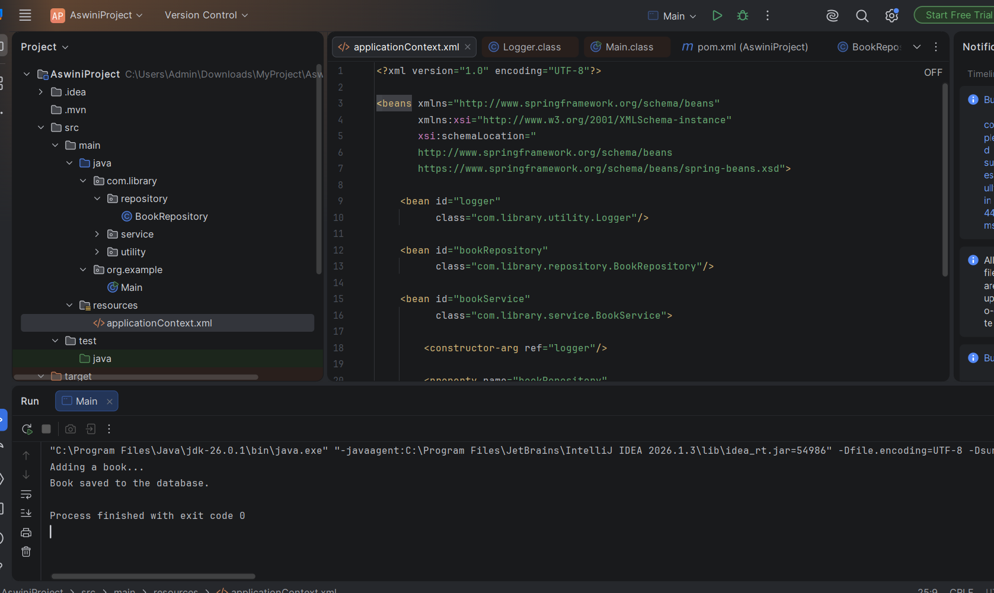

Exercise 2: Implementing Dependency Injection
Scenario:
In the library management application, you need to manage the dependencies between the BookService and BookRepository classes using Spring's IoC and DI.

BookRepository.java

package com.library.repository;

public class BookRepository {

public void saveBook() {
System.out.println("Book saved to the database.");
}
}

BookService.java

package com.library.service;

import com.library.repository.BookRepository;
import com.library.utility.Logger;

public class BookService {

private BookRepository bookRepository;
private Logger logger;

public BookService(Logger logger) {
this.logger = logger;
}

public void setBookRepository(BookRepository bookRepository) {
this.bookRepository = bookRepository;
}

public void addBook() {
logger.log("Adding a book...");
bookRepository.saveBook();
}
}

applicationContext.xml

<?xml version="1.0" encoding="UTF-8"?>

<beans xmlns="http://www.springframework.org/schema/beans"
xmlns:xsi="http://www.w3.org/2001/XMLSchema-instance"
xsi:schemaLocation="
http://www.springframework.org/schema/beans
https://www.springframework.org/schema/beans/spring-beans.xsd">

<!-- Logger Bean -->
<bean id="logger"
class="com.library.utility.Logger"/>

<!-- BookRepository Bean -->
<bean id="bookRepository"
class="com.library.repository.BookRepository"/>

<!-- BookService Bean -->
<bean id="bookService"
class="com.library.service.BookService">

<!-- Constructor Injection -->
<constructor-arg ref="logger"/>

<!-- Setter Injection -->
<property name="bookRepository"
ref="bookRepository"/>

</bean>

</beans>

OUTPUT:
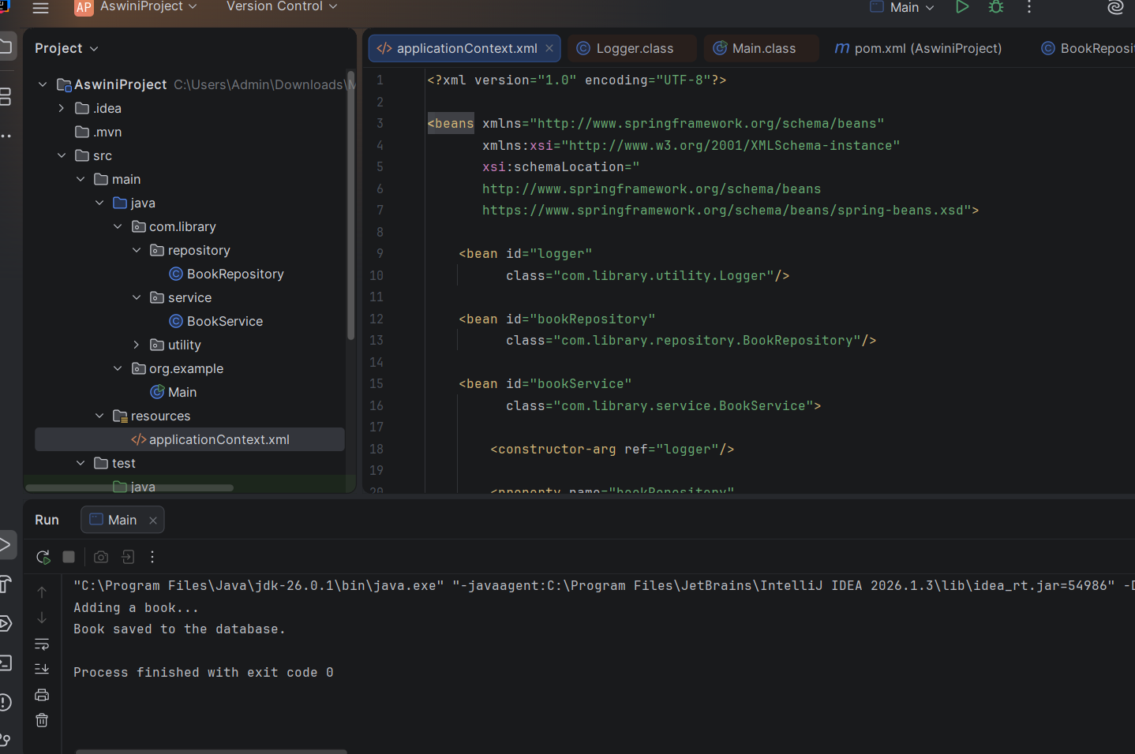

Exercise 4: Creating and Configuring a Maven Project

BookRepository.java

package com.library.repository;

public class BookRepository {

public void saveBook() {
System.out.println("Book saved to the database.");
}
}

BookService.java

package com.library.service;

import com.library.repository.BookRepository;
import com.library.utility.Logger;

public class BookService {

private BookRepository bookRepository;
private Logger logger;

public BookService(Logger logger) {
this.logger = logger;
}

public void setBookRepository(BookRepository bookRepository) {
this.bookRepository = bookRepository;
}

public void addBook() {
logger.log("Adding a book...");
bookRepository.saveBook();
}
}

POM.XML

<?xml version="1.0" encoding="UTF-8"?>

<project xmlns="http://maven.apache.org/POM/4.0.0"
xmlns:xsi="http://www.w3.org/2001/XMLSchema-instance"
xsi:schemaLocation="http://maven.apache.org/POM/4.0.0
http://maven.apache.org/xsd/maven-4.0.0.xsd">

<modelVersion>4.0.0</modelVersion>

<groupId>org.example</groupId>
<artifactId>SpringExample</artifactId>
<version>1.0-SNAPSHOT</version>

<properties>
<maven.compiler.source>17</maven.compiler.source>
<maven.compiler.target>17</maven.compiler.target>
<project.build.sourceEncoding>UTF-8</project.build.sourceEncoding>
</properties>

<dependencies>

<!-- Spring Context -->
<dependency>
<groupId>org.springframework</groupId>
<artifactId>spring-context</artifactId>
<version>5.3.33</version>
</dependency>

<!-- Spring AOP -->
<dependency>
<groupId>org.springframework</groupId>
<artifactId>spring-aop</artifactId>
<version>5.3.33</version>
</dependency>

<!-- Spring Web MVC -->
<dependency>
<groupId>org.springframework</groupId>
<artifactId>spring-webmvc</artifactId>
<version>5.3.33</version>
</dependency>

</dependencies>

<build>
<plugins>

<!-- Maven Compiler Plugin -->
<plugin>
<groupId>org.apache.maven.plugins</groupId>
<artifactId>maven-compiler-plugin</artifactId>
<version>3.8.1</version>

<configuration>
<source>17</source>
<target>17</target>
</configuration>

</plugin>

</plugins>
</build>

</project>

OUTPUT

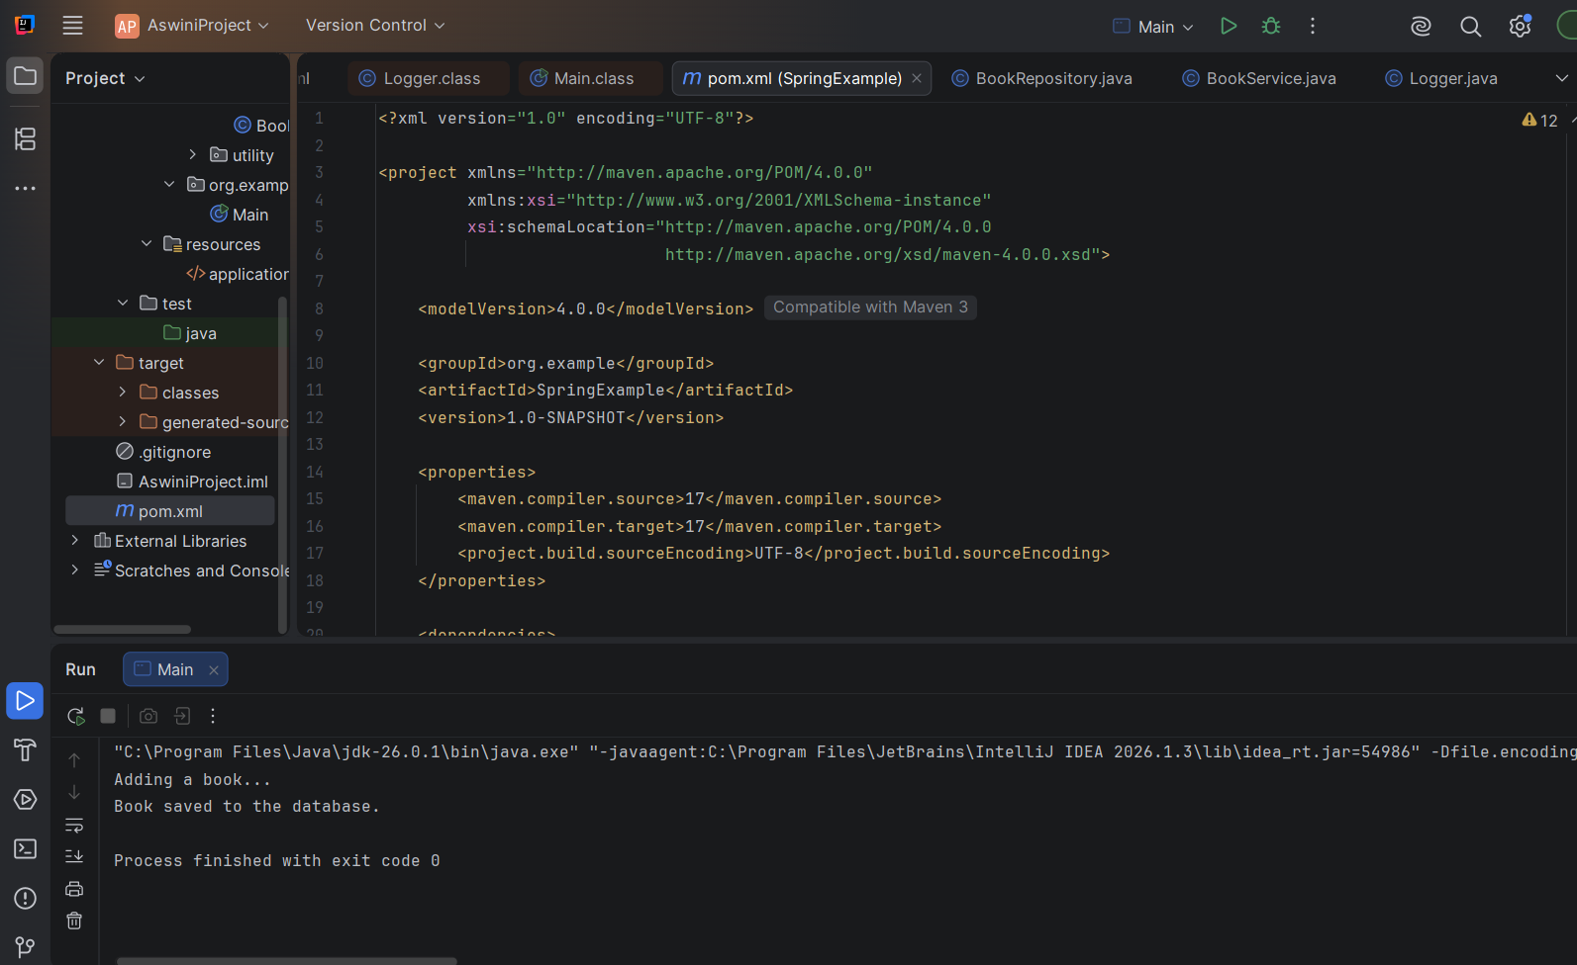

Exercise 5: Configuring the Spring IoC Container
Scenario:
The library management application requires a central configuration for beans and dependencies.

Solution:

BookRepository.java
package com.library.repository;

public class BookRepository {

public void saveBook() {
System.out.println("Book saved to the database.");
}
}

BookService.java

package com.library.service;

import com.library.repository.BookRepository;
import com.library.utility.Logger;

public class BookService {

private BookRepository bookRepository;
private Logger logger;

public BookService(Logger logger) {
this.logger = logger;
}

public void setBookRepository(BookRepository bookRepository) {
this.bookRepository = bookRepository;
}

public void addBook() {
logger.log("Adding a book...");
bookRepository.saveBook();
}
}

ApplicationContext.xml
<?xml version="1.0" encoding="UTF-8"?>
<beans xmlns="http://www.springframework.org/schema/beans"
xmlns:xsi="http://www.w3.org/2001/XMLSchema-instance"
xsi:schemaLocation="
http://www.springframework.org/schema/beans
https://www.springframework.org/schema/beans/spring-beans.xsd">
<bean id="logger"
class="com.library.utility.Logger"/>
<bean id="bookRepository"
class="com.library.repository.BookRepository"/>
<bean id="bookService"
class="com.library.service.BookService">
<constructor-arg ref="logger"/>
<property name="bookRepository"
ref="bookRepository"/>
</bean>
</beans>

OUTPUT:
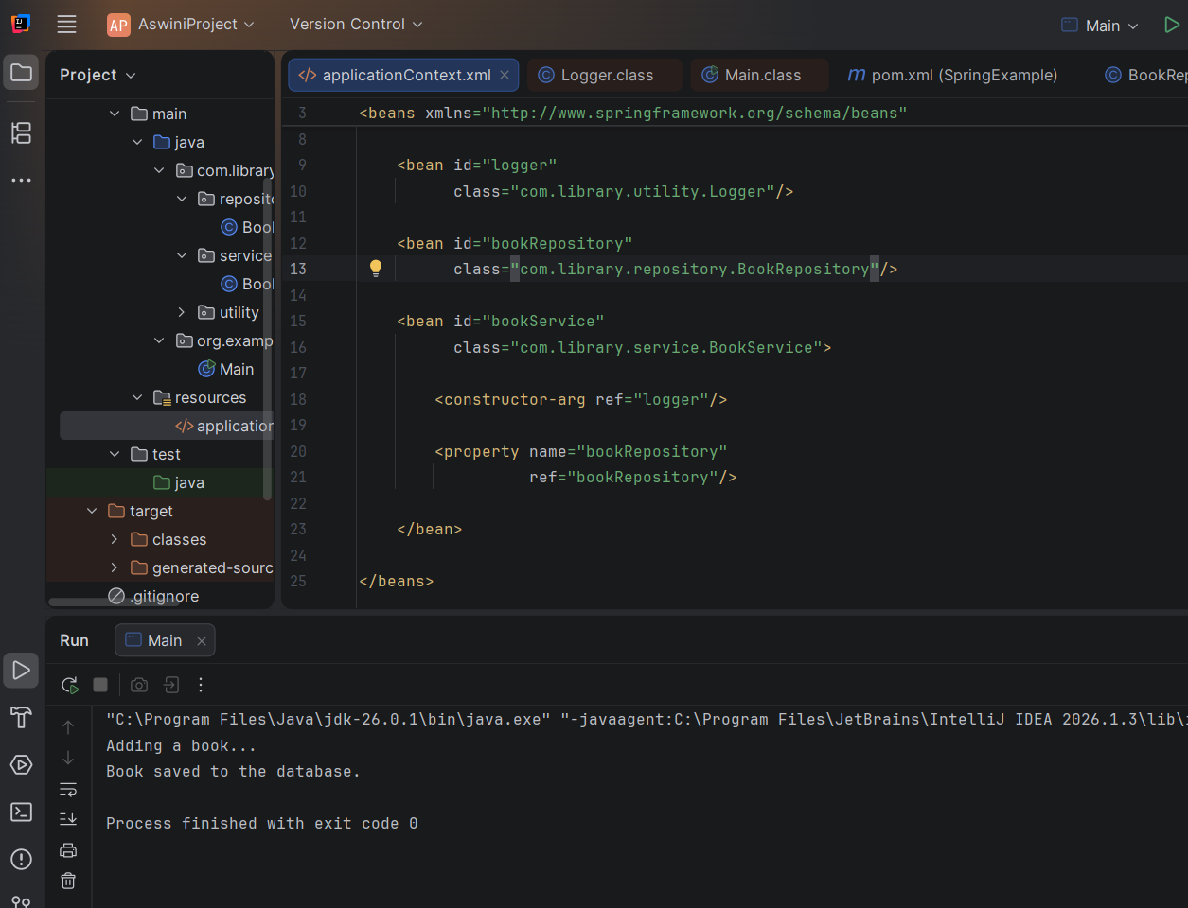

Exercise 7: Implementing Constructor and Setter Injection
Scenario:
The library management application requires both constructor and setter injection for better control over bean initialization.

BookRepository.java
package com.library.repository;

public class BookRepository {

public void saveBook() {
System.out.println("Book saved to the database.");
}
}

BookService.java

package com.library.service;

import com.library.repository.BookRepository;
import com.library.utility.Logger;

public class BookService {

private BookRepository bookRepository;
private Logger logger;

public BookService(Logger logger) {
this.logger = logger;
}

public void setBookRepository(BookRepository bookRepository) {
this.bookRepository = bookRepository;
}

public void addBook() {
logger.log("Adding a book...");
bookRepository.saveBook();
}
}

Logger.java
package com.library.utility;
public class Logger {
public void log(String message) {
System.out.println(message);
}
}

OUTPUT:

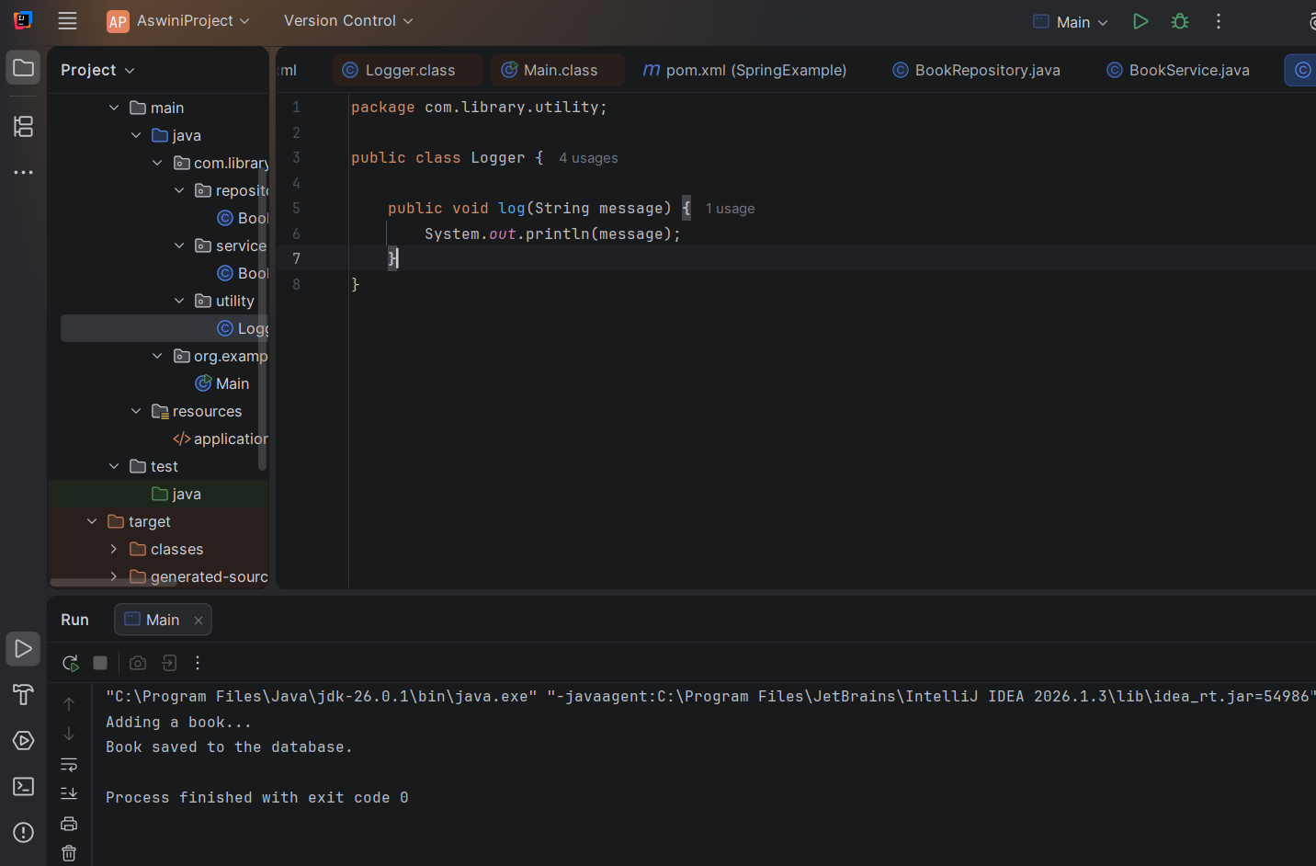

Exercise 9: Creating a Spring Boot Application
Scenario:
You need to create a Spring Boot application for the library management system to simplify configuration and deployment.

Solution:
LibraryManagementApplication.java

package com.example.demo;
import org.springframework.boot.SpringApplication;
import org.springframework.boot.autoconfigure.SpringBootApplication;
import org.springframework.boot.autoconfigure.domain.EntityScan;
import org.springframework.data.jpa.repository.config.EnableJpaRepositories;
import org.springframework.context.annotation.ComponentScan;
@SpringBootApplication
@ComponentScan(basePackages = {"com.example"})
@EnableJpaRepositories(basePackages = "com.example.repository")
@EntityScan(basePackages = "com.example.model")
public class LibraryManagementApplication {
public static void main(String[] args) {
SpringApplication.run(LibraryManagementApplication.class, args);
}
}

Book.java
package com.example.model;
import jakarta.persistence.*;
@Entity
public class Book {
@Id
@GeneratedValue(strategy = GenerationType.IDENTITY)
private Long id;
private String title;
private String author;
private String isbn;
public Book() {}
public Book(String title, String author, String isbn) {
this.title = title;
this.author = author;
this.isbn = isbn;
}
public Long getId() { return id; }
public void setId(Long id) { this.id = id; }
public String getTitle() { return title; }
public void setTitle(String title) { this.title = title; }
public String getAuthor() { return author; }
public void setAuthor(String author) { this.author = author; }
public String getIsbn() { return isbn; }
public void setIsbn(String isbn) { this.isbn = isbn; }
}

BookController.java
import com.example.model.Book;
import com.example.repository.BookRepository;
import org.springframework.beans.factory.annotation.Autowired;
import org.springframework.web.bind.annotation.*;

import java.util.List;
import java.util.Optional;

@RestController
@RequestMapping("/books")
public class BookController {

@Autowired
private BookRepository bookRepository;

@PostMapping
public Book createBook(@RequestBody Book book) {
return bookRepository.save(book);
}

@GetMapping
public List<Book> getAllBooks() {
return bookRepository.findAll();
}

@GetMapping("/{id}")
public Book getBookById(@PathVariable Long id) {
return bookRepository.findById(id)
.orElseThrow(() -> new RuntimeException("Book not found with id: " + id));
}
@PutMapping("/{id}")
public Book updateBook(@PathVariable Long id, @RequestBody Book updatedBook) {
return bookRepository.findById(id)
.map(book -> {
book.setTitle(updatedBook.getTitle());
book.setAuthor(updatedBook.getAuthor());
book.setIsbn(updatedBook.getIsbn());
return bookRepository.save(book);
})
.orElseThrow(() -> new RuntimeException("Book not found with id: " + id));
}

@DeleteMapping("/{id}")
public String deleteBook(@PathVariable Long id) {
if (bookRepository.existsById(id)) {
bookRepository.deleteById(id);
return "Book deleted with id: " + id;
} else {
return "Book not found with id: " + id;
}
}
}

BookRepository.java
package com.example.repository;

import com.example.model.Book;
import org.springframework.data.jpa.repository.JpaRepository;

public interface BookRepository extends JpaRepository<Book, Long> {
}

OUTPUT:

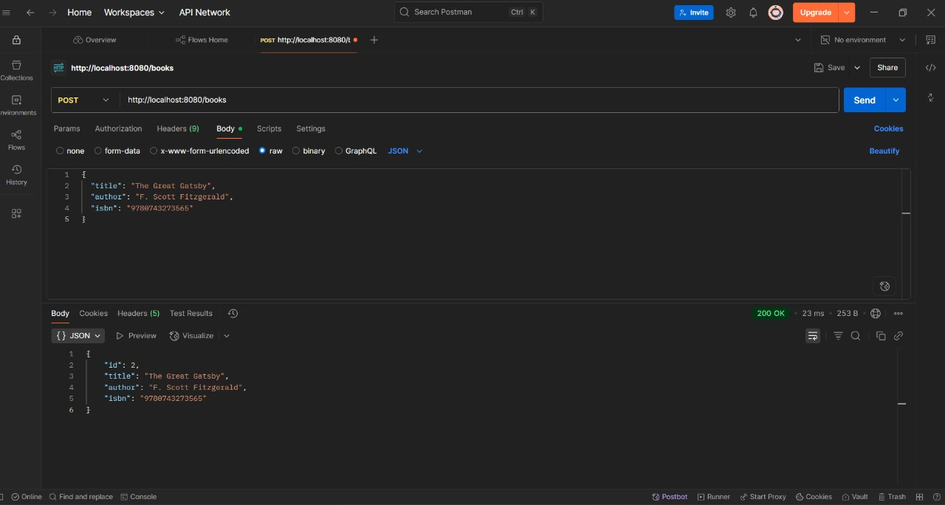

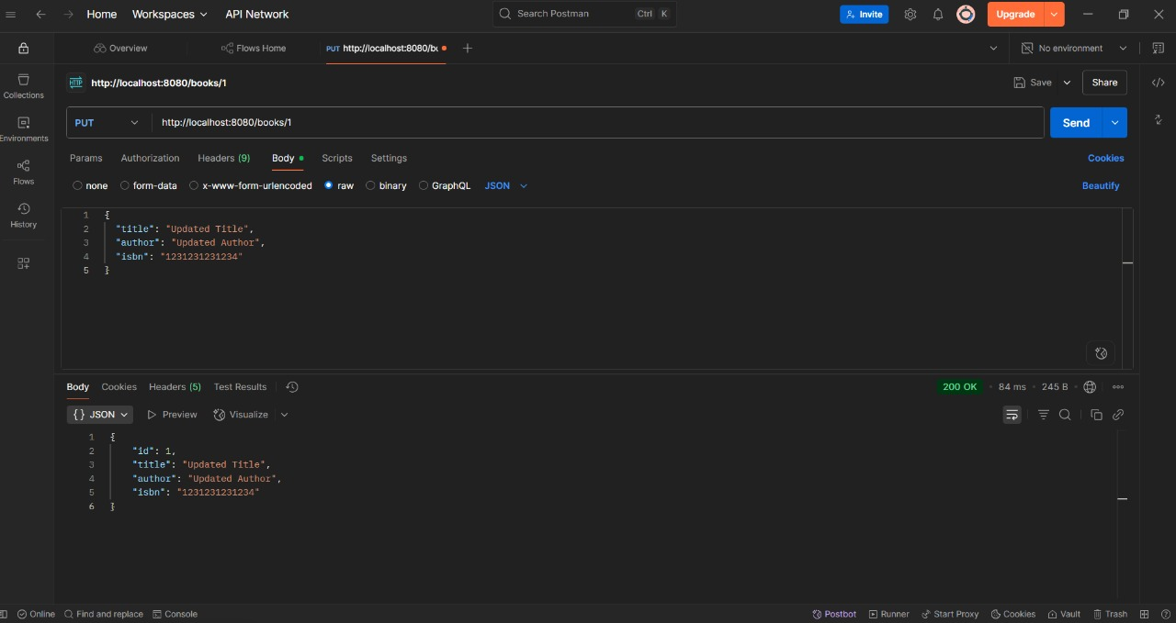
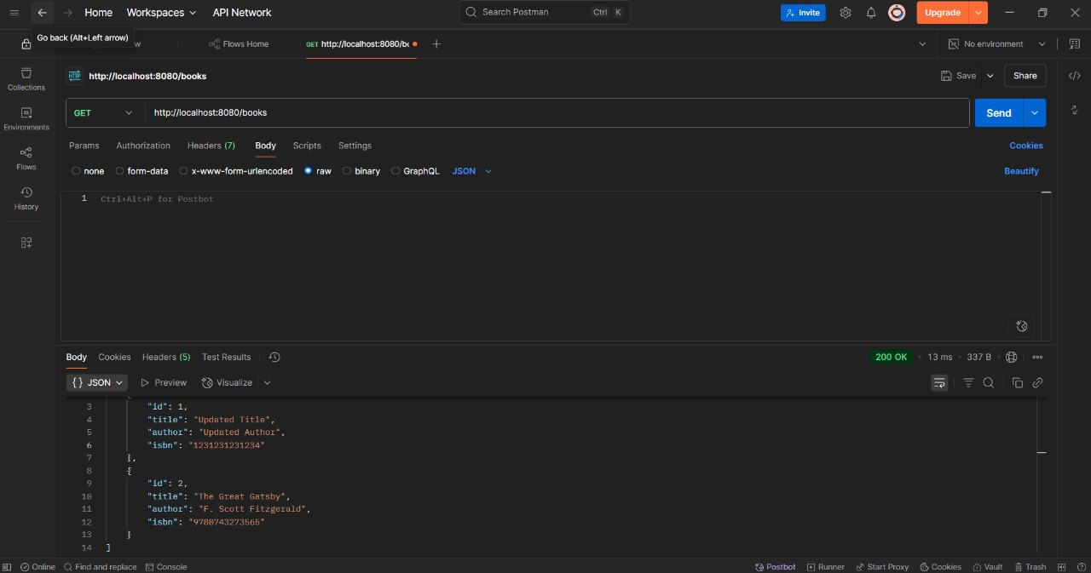
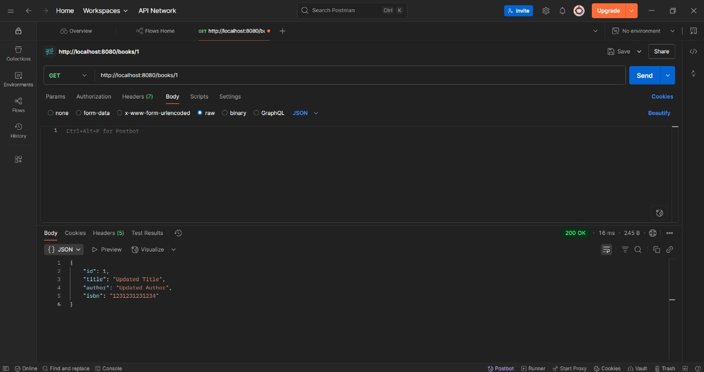

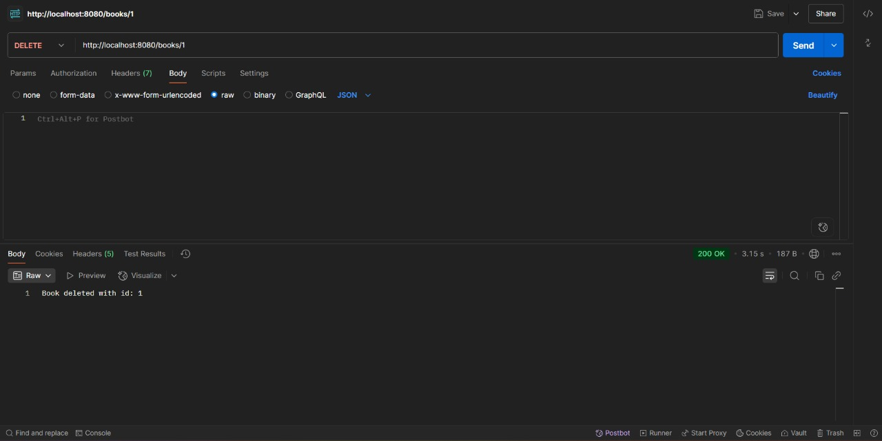

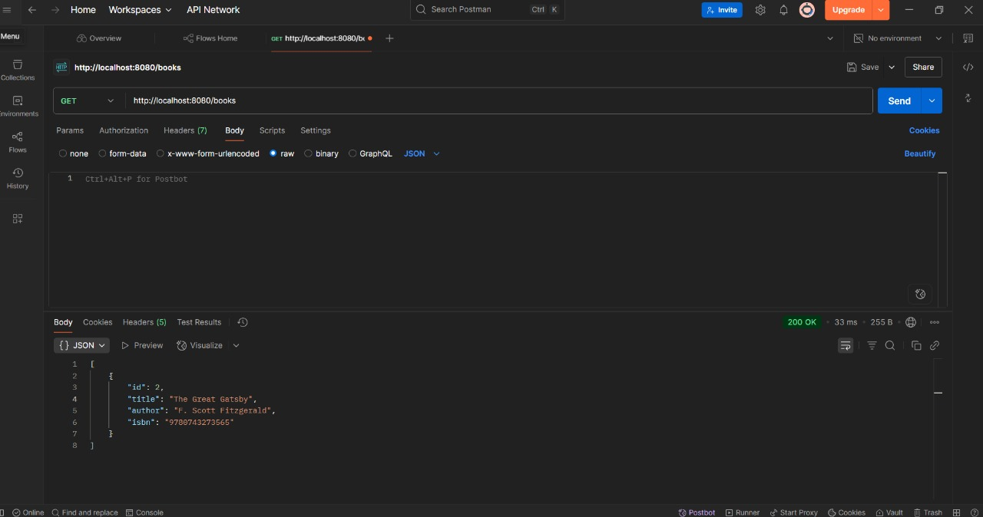

- Spring Data JPA Hands-on Exercises:

Exercise 1: Spring Data JPA - Quick Example

Solution:
Country.java
package com.cognizant.orm_learn.model;

import jakarta.persistence.Column;
import jakarta.persistence.Entity;
import jakarta.persistence.Id;
import jakarta.persistence.Table;

@Entity
@Table(name = "country")
public class Country {

@Id
@Column(name = "code")
private String code;

@Column(name = "name")
private String name;

public String getCode() {
return code;
}

public void setCode(String code) {
this.code = code;
}

public String getName() {
return name;
}

public void setName(String name) {
this.name = name;
}

@Override
public String toString() {
return "Country [code=" + code + ", name=" + name + "]";
}
}
CountryService.java
package com.cognizant.orm_learn.service;

import java.util.List;
import java.util.Optional;

import org.springframework.beans.factory.annotation.Autowired;
import org.springframework.stereotype.Service;

import com.cognizant.orm_learn.model.Country;
import com.cognizant.orm_learn.repository.CountryRepository;

import jakarta.transaction.Transactional;

@Service
public class CountryService {

@Autowired
private CountryRepository countryRepository;

@Transactional
public List<Country> getAllCountries() {
return countryRepository.findAll();
}

@Transactional
public void addCountry(Country country) {
if (!countryRepository.existsById(country.getCode())) {
countryRepository.save(country);
}
}

@Transactional
public Country findCountryByCode(String code) {
Optional<Country> result = countryRepository.findById(code);
return result.orElse(null);
}

@Transactional
public void deleteCountry(String code) {
countryRepository.deleteById(code);
}
}

CountryRepository.java
package com.cognizant.orm_learn.repository;

import org.springframework.data.jpa.repository.JpaRepository;
import org.springframework.stereotype.Repository;

import com.cognizant.orm_learn.model.Country;

@Repository
public interface CountryRepository extends JpaRepository<Country, String> {
}

OrmLearnApplication.java
package com.cognizant.orm_learn;
import com.cognizant.orm_learn.model.Country;
import com.cognizant.orm_learn.service.CountryService;
import java.util.List;
import org.slf4j.Logger;
import org.slf4j.LoggerFactory;
import org.springframework.boot.SpringApplication;
import org.springframework.boot.autoconfigure.SpringBootApplication;
import org.springframework.context.ApplicationContext;
@SpringBootApplication
public class OrmLearnApplication {
private static final Logger LOGGER = LoggerFactory.getLogger(OrmLearnApplication.class);
private static CountryService countryService;
public static void main(String[] args) {
ApplicationContext context = SpringApplication.run(OrmLearnApplication.class, args);
countryService = context.getBean(CountryService.class);
LOGGER.info("Inside main");

testGetAllCountries();
testAddCountry();
testFindCountryByCode();

testDeleteCountry();

testGetAllCountries();
}
private static void testGetAllCountries() {
LOGGER.info("Start");
List<Country> countries = countryService.getAllCountries();
LOGGER.debug("countries={}", countries);
LOGGER.info("End");
}
private static void testAddCountry() {
LOGGER.info("Start - Add Country");
Country country = new Country();
country.setCode("JP");
country.setName("Japan");
countryService.addCountry(country);
LOGGER.info("Added country: {}", country);
LOGGER.info("End");
}
private static void testFindCountryByCode() {
LOGGER.info("Start - Find Country");

Country country = countryService.findCountryByCode("JP");
LOGGER.info("Country found: {}", country);
LOGGER.info("End");
}
private static void testDeleteCountry() {
LOGGER.info("Start - Delete Country");
countryService.deleteCountry("JP");
LOGGER.info("Deleted country with code JP");
LOGGER.info("End");
}
}

Output:
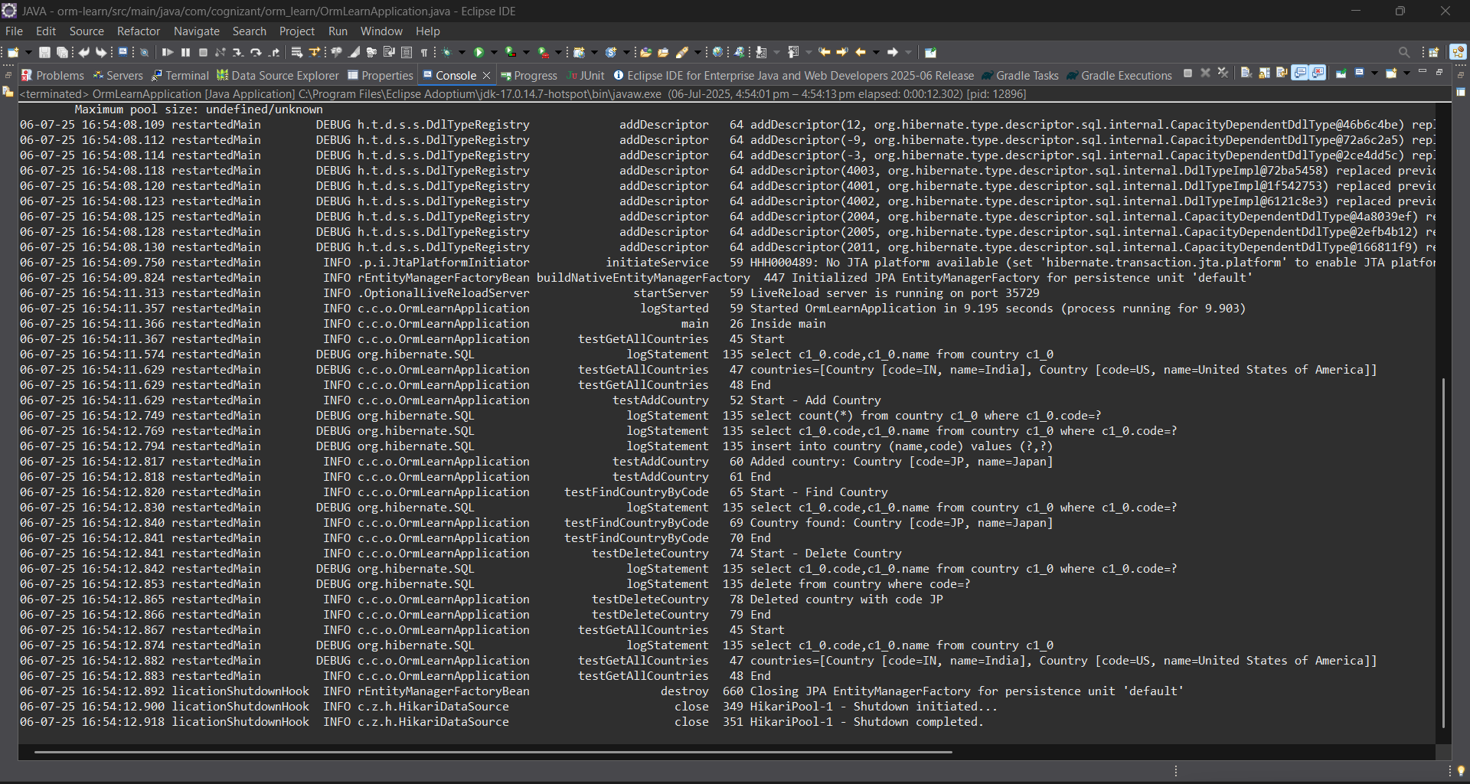

Exercise 4: Difference between JPA, Hibernate and Spring Data JPA
Java Persistence API (JPA)
- JSR 338 Specification for persisting, reading and managing data from Java objects
- Does not contain concrete implementation of the specification
- Hibernate is one of the implementation of JPA
Hibernate
- ORM Tool that implements JPA
Spring Data JPA
- Does not have JPA implementation, but reduces boiler plate code
- This is another level of abstraction over JPA implementation provider like Hibernate
- Manages transactions

Solution:
Employee.java
package com.cognizant.orm_learn.model;
import jakarta.persistence.*;
import java.util.Date;
import java.util.Set;
@Entity
@Table(name = "employee")
public class Employee {
@Id
@GeneratedValue(strategy = GenerationType.IDENTITY)
@Column(name = "em_id")
private int id;
@Column(name = "em_name")
private String name;
@Column(name = "em_salary")
private double salary;
@Column(name = "em_permanent")
private boolean permanent;
@Column(name = "em_date_of_birth")
private Date dateOfBirth;
@ManyToOne
@JoinColumn(name = "em_dp_id")
private Department department;
@ManyToMany(fetch = FetchType.EAGER)
@JoinTable(
name = "employee_skill",
joinColumns = @JoinColumn(name = "es_em_id"),
inverseJoinColumns = @JoinColumn(name = "es_sk_id")
)
private Set<Skill> skillList;
public int getId() { return id; }
public void setId(int id) { this.id = id; }
public String getName() { return name; }
public void setName(String name) { this.name = name; }
public double getSalary() { return salary; }
public void setSalary(double salary) { this.salary = salary; }
public boolean isPermanent() { return permanent; }
public void setPermanent(boolean permanent) { this.permanent = permanent; }
public Date getDateOfBirth() { return dateOfBirth; }
public void setDateOfBirth(Date dateOfBirth) { this.dateOfBirth = dateOfBirth; }
public Department getDepartment() { return department; }
public void setDepartment(Department department) { this.department = department; }
public Set<Skill> getSkillList() { return skillList; }
public void setSkillList(Set<Skill> skillList) { this.skillList = skillList; }
@Override
public String toString() {
return "Employee [id=" + id + ", name=" + name + ", salary=" + salary +
", permanent=" + permanent + ", dateOfBirth=" + dateOfBirth + "]";
}
}
Department.java
package com.cognizant.orm_learn.model;
import jakarta.persistence.*;
import java.util.Set;
@Entity
@Table(name = "department")
public class Department {
@Id
@GeneratedValue(strategy = GenerationType.IDENTITY)
@Column(name = "dp_id")
private int id;
@Column(name = "dp_name")
private String name;
@OneToMany(mappedBy = "department", fetch = FetchType.EAGER)
private Set<Employee> employeeList;
public int getId() {
return id;
}
public void setId(int id) {
this.id = id;
}
public String getName() {
return name;
}
public void setName(String name) {
this.name = name;
}
public Set<Employee> getEmployeeList() {
return employeeList;
}
public void setEmployeeList(Set<Employee> employeeList) {
this.employeeList = employeeList;
}
@Override
public String toString() {
return "Department [id=" + id + ", name=" + name + "]";
}
}
Skill.java
package com.cognizant.orm_learn.model;
import jakarta.persistence.*;
import java.util.Set;
@Entity
@Table(name = "skill")
public class Skill {
@Id
@GeneratedValue(strategy = GenerationType.IDENTITY)
@Column(name = "sk_id")
private int id;
@Column(name = "sk_name")
private String name;
@ManyToMany(mappedBy = "skillList")
private Set<Employee> employeeList;
public int getId() {
return id;
}
public void setId(int id) {
this.id = id;
}
public String getName() {
return name;
}
public void setName(String name) {
this.name = name;
}
public Set<Employee> getEmployeeList() {
return employeeList;
}
public void setEmployeeList(Set<Employee> employeeList) {
this.employeeList = employeeList;
}
@Override
public String toString() {
return "Skill [id=" + id + ", name=" + name + "]";
}
}
EmployeeRepository.java
package com.cognizant.orm_learn.repository;
import org.springframework.data.jpa.repository.JpaRepository;
import com.cognizant.orm_learn.model.Employee;
public interface EmployeeRepository extends JpaRepository<Employee, Integer> {}
DepartmentRepository.java
package com.cognizant.orm_learn.repository;
import org.springframework.data.jpa.repository.JpaRepository;
import com.cognizant.orm_learn.model.Department;
public interface DepartmentRepository extends JpaRepository<Department, Integer> {}
SkillRepository.java
package com.cognizant.orm_learn.repository;
import org.springframework.data.jpa.repository.JpaRepository;
import com.cognizant.orm_learn.model.Skill;
public interface SkillRepository extends JpaRepository<Skill, Integer> {}
EmployeeService.java
package com.cognizant.orm_learn.service;
import com.cognizant.orm_learn.model.Employee;
import com.cognizant.orm_learn.repository.EmployeeRepository;
import org.springframework.beans.factory.annotation.Autowired;
import org.springframework.stereotype.Service;
import jakarta.transaction.Transactional;
import org.slf4j.Logger;
import org.slf4j.LoggerFactory;
@Service
public class EmployeeService {
private static final Logger LOGGER = LoggerFactory.getLogger(EmployeeService.class);
@Autowired
private EmployeeRepository employeeRepository;
@Transactional
public Employee get(int id) {
LOGGER.info("Start");
return employeeRepository.findById(id).get();
}
@Transactional
public void save(Employee employee) {
LOGGER.info("Start");
employeeRepository.save(employee);
LOGGER.info("End");
}
}
DepartmentService.java
package com.cognizant.orm_learn.service;
import com.cognizant.orm_learn.model.Department;
import com.cognizant.orm_learn.repository.DepartmentRepository;
import org.springframework.beans.factory.annotation.Autowired;
import org.springframework.stereotype.Service;
import jakarta.transaction.Transactional;
@Service
public class DepartmentService {
@Autowired
private DepartmentRepository departmentRepository;
@Transactional
public Department get(int id) {
return departmentRepository.findById(id).get();
}
@Transactional
public void save(Department department) {
departmentRepository.save(department);
}
}
SkillService.java
package com.cognizant.orm_learn.service;
import com.cognizant.orm_learn.model.Skill;
import com.cognizant.orm_learn.repository.SkillRepository;
import org.springframework.beans.factory.annotation.Autowired;
import org.springframework.stereotype.Service;
import jakarta.transaction.Transactional;
@Service
public class SkillService {
@Autowired
private SkillRepository skillRepository;
@Transactional
public Skill get(int id) {
return skillRepository.findById(id).get();
}
@Transactional
public void save(Skill skill) {
skillRepository.save(skill);
}
}
OrmLearnApplication.java
package com.cognizant.orm_learn;
import com.cognizant.orm_learn.model.Department;
import com.cognizant.orm_learn.model.Employee;
import com.cognizant.orm_learn.model.Skill;
import com.cognizant.orm_learn.service.DepartmentService;
import com.cognizant.orm_learn.service.EmployeeService;
import com.cognizant.orm_learn.service.SkillService;
import org.slf4j.Logger;
import org.slf4j.LoggerFactory;
import org.springframework.boot.SpringApplication;
import org.springframework.boot.autoconfigure.SpringBootApplication;
import org.springframework.context.ApplicationContext;
import java.util.Date;
import java.util.HashSet;
import java.util.Set;
@SpringBootApplication
public class OrmLearnApplication {
private static final Logger LOGGER = LoggerFactory.getLogger(OrmLearnApplication.class);
private static EmployeeService employeeService;
private static DepartmentService departmentService;
private static SkillService skillService;
public static void main(String[] args) {
ApplicationContext context = SpringApplication.run(OrmLearnApplication.class, args);
employeeService = context.getBean(EmployeeService.class);
departmentService = context.getBean(DepartmentService.class);
skillService = context.getBean(SkillService.class);
LOGGER.info("Inside main");
testAddEmployee();
testUpdateEmployee();
testGetDepartment();
testAddSkillToEmployee();
}
private static void testAddEmployee() {
LOGGER.info("Start - testAddEmployee");

Employee employee = new Employee();
employee.setName("Jane Doe");
employee.setSalary(60000.0);
employee.setPermanent(true);
employee.setDateOfBirth(new Date());
Department department = departmentService.get(1);

Set<Skill> skillList = new HashSet<>();
skillList.add(skillService.get(1));
skillList.add(skillService.get(2));
employee.setSkillList(skillList);

employeeService.save(employee);

LOGGER.debug("Employee added: {}", employee);
LOGGER.info("End");
}

private static void testGetEmployee() {
LOGGER.info("Start - testGetEmployee");
Employee employee = employeeService.get(1); // use valid employee id
LOGGER.debug("Employee: {}", employee);
LOGGER.debug("Department: {}", employee.getDepartment());
LOGGER.debug("Skills: {}", employee.getSkillList());
LOGGER.info("End");
}
private static void testUpdateEmployee() {
LOGGER.info("Start - testUpdateEmployee");
Employee employee = employeeService.get(1); // use valid employee id
Department newDept = departmentService.get(2); // different department ID
employee.setDepartment(newDept);
employeeService.save(employee);
LOGGER.debug("Updated Employee: {}", employee);
LOGGER.info("End");
}
private static void testGetDepartment() {
LOGGER.info("Start - testGetDepartment");
Department department = departmentService.get(1); // department with multiple employees
LOGGER.debug("Department: {}", department);
LOGGER.debug("Employees: {}", department.getEmployeeList());
LOGGER.info("End");
}
private static void testAddSkillToEmployee() {
LOGGER.info("Start - testAddSkillToEmployee");
Employee employee = employeeService.get(1); // valid employee id
Skill skill = skillService.get(2); // valid skill id not already assigned
Set<Skill> skillList = employee.getSkillList();
if (skillList == null) {
skillList = new HashSet<>();
}
skillList.add(skill);

employee.setSkillList(skillList);
employeeService.save(employee);
LOGGER.debug("Updated Employee with new skill: {}", employee);
LOGGER.info("End");
}
}
Output:
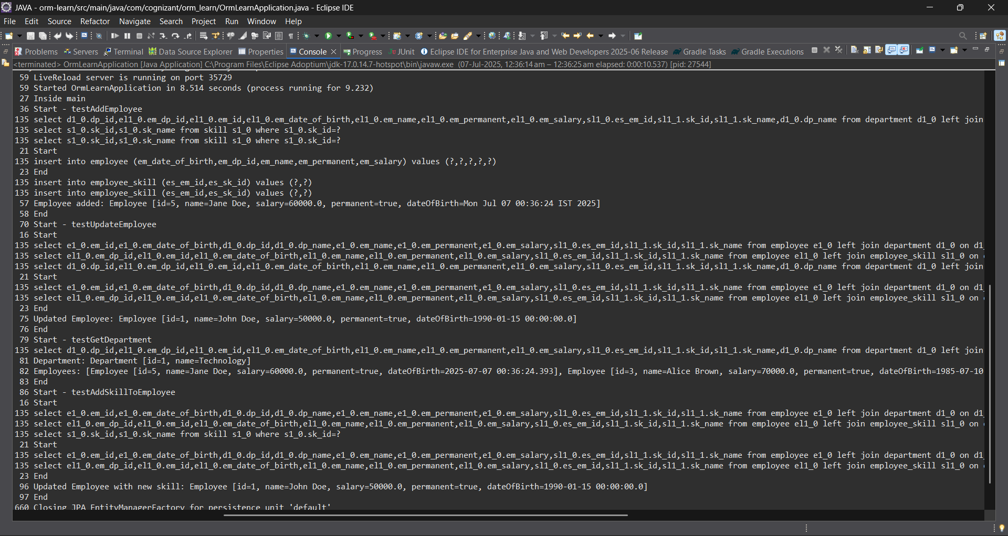

Exercise 5: Implement services for managing Country
An application requires for features to be implemented with regards to country. These features needs to be supported by implementing them as service using Spring Data JPA.
- Find a country based on country code
- Add new country
- Update country
- Delete country
- Find list of countries matching a partial country name

Solution:
Country.java:
package com.cognizant.orm_learn.model;

import jakarta.persistence.Column;
import jakarta.persistence.Entity;
import jakarta.persistence.Id;
import jakarta.persistence.Table;

@Entity
@Table(name = "country")
public class Country {

@Id
@Column(name = "code")
private String code;

@Column(name = "name")
private String name;

public String getCode() {
return code;
}

public void setCode(String code) {
this.code = code;
}

public String getName() {
return name;
}

public void setName(String name) {
this.name = name;
}

@Override
public String toString() {
return "Country [code=" + code + ", name=" + name + "]";
}
}

CountryService.java
package com.cognizant.orm_learn.service;
import com.cognizant.orm_learn.model.Country;
import java.util.List;
public interface CountryService {
Country findCountryByCode(String code);
void addCountry(Country country);
void updateCountry(Country country);
void deleteCountry(String code);

List<Country> findCountriesByPartialName(String name);
List<Country> getAllCountries();
}

CountryServiceImpl.java
package com.cognizant.orm_learn.service;
import com.cognizant.orm_learn.model.Country;
import com.cognizant.orm_learn.repository.CountryRepository;
import jakarta.transaction.Transactional;
import org.springframework.beans.factory.annotation.Autowired;
import org.springframework.stereotype.Service;
import java.util.List;
@Service
@Transactional
public class CountryServiceImpl implements CountryService {
@Autowired
private CountryRepository countryRepository;
@Override
public Country findCountryByCode(String code) {
return countryRepository.findById(code).orElse(null);
}
@Override
public void addCountry(Country country) {
countryRepository.save(country);
}
@Override
public void updateCountry(Country country) {
Country existing = countryRepository.findById(country.getCode()).orElse(null);
if (existing != null) {
existing.setName(country.getName());
countryRepository.save(existing);
}
}
@Override
public void deleteCountry(String code) {
countryRepository.deleteById(code);
}
@Override
public List<Country> findCountriesByPartialName(String name) {
return countryRepository.findByNameContainingIgnoreCase(name);
}
@Override
public List<Country> getAllCountries() {
return countryRepository.findAll();
}
}

OrmLearnApplication.java

package com.cognizant.orm_learn;
import com.cognizant.orm_learn.model.Country;
import com.cognizant.orm_learn.service.CountryService;
import java.util.List;
import org.slf4j.Logger;
import org.slf4j.LoggerFactory;
import org.springframework.boot.SpringApplication;
import org.springframework.boot.autoconfigure.SpringBootApplication;
import org.springframework.context.ApplicationContext;
@SpringBootApplication
public class OrmLearnApplication {
private static final Logger LOGGER = LoggerFactory.getLogger(OrmLearnApplication.class);
private static CountryService countryService;
public static void main(String[] args) {
ApplicationContext context = SpringApplication.run(OrmLearnApplication.class, args);
countryService = context.getBean(CountryService.class);
LOGGER.info("Inside main");
testGetAllCountries();
testAddCountry();

testFindCountryByCode();

testDeleteCountry();
testGetAllCountries();
testFindCountriesByPartialName();
}
private static void testGetAllCountries() {
LOGGER.info("Start - Get All Countries");
List<Country> countries = countryService.getAllCountries();
LOGGER.debug("countries={}", countries);
LOGGER.info("End");
}
private static void testAddCountry() {
LOGGER.info("Start - Add Country");
Country country = new Country();
country.setCode("JP");
country.setName("Japan");

countryService.addCountry(country);
LOGGER.info("Added country: {}", country);
LOGGER.info("End");
}
private static void testFindCountryByCode() {
LOGGER.info("Start - Find Country by Code");
Country country = countryService.findCountryByCode("JP");
LOGGER.info("Country found: {}", country);
LOGGER.info("End");
}
private static void testDeleteCountry() {
LOGGER.info("Start - Delete Country");
countryService.deleteCountry("JP");
LOGGER.info("Deleted country with code JP");
LOGGER.info("End");
}
private static void testFindCountriesByPartialName() {
LOGGER.info("Start - Find Countries by Partial Name");
String partialName = "Uni"; // Example input
List<Country> countries = countryService.findCountriesByPartialName(partialName);
LOGGER.info("Countries matching '{}': {}", partialName, countries);
LOGGER.info("End");
}
}

Output:
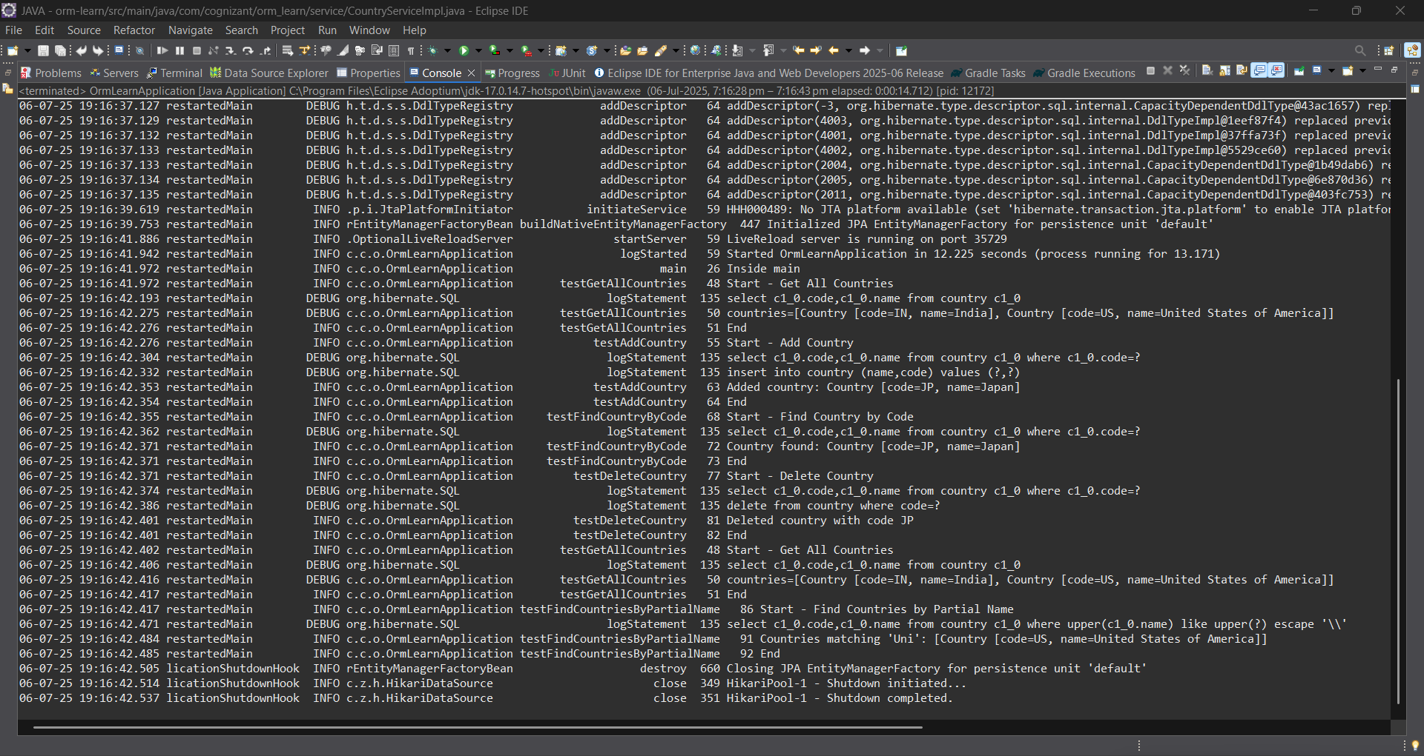

Exercise 4: Difference between JPA, Hibernate and Spring Data JPA
Java Persistence API (JPA)
- JSR 338 Specification for persisting, reading and managing data from Java objects
- Does not contain concrete implementation of the specification
- Hibernate is one of the implementation of JPA
Hibernate
- ORM Tool that implements JPA
Spring Data JPA
- Does not have JPA implementation, but reduces boiler plate code
- This is another level of abstraction over JPA implementation provider like Hibernate
- Manages transactions

Solution:
Employee.java
package com.cognizant.orm_learn.model;
import jakarta.persistence.*;
import java.util.Date;
import java.util.Set;
@Entity
@Table(name = "employee")
public class Employee {
@Id
@GeneratedValue(strategy = GenerationType.IDENTITY)
@Column(name = "em_id")
private int id;
@Column(name = "em_name")
private String name;
@Column(name = "em_salary")
private double salary;
@Column(name = "em_permanent")
private boolean permanent;
@Column(name = "em_date_of_birth")
private Date dateOfBirth;
@ManyToOne
@JoinColumn(name = "em_dp_id")
private Department department;
@ManyToMany(fetch = FetchType.EAGER)
@JoinTable(
name = "employee_skill",
joinColumns = @JoinColumn(name = "es_em_id"),
inverseJoinColumns = @JoinColumn(name = "es_sk_id")
)
private Set<Skill> skillList;
public int getId() { return id; }
public void setId(int id) { this.id = id; }
public String getName() { return name; }
public void setName(String name) { this.name = name; }
public double getSalary() { return salary; }
public void setSalary(double salary) { this.salary = salary; }
public boolean isPermanent() { return permanent; }
public void setPermanent(boolean permanent) { this.permanent = permanent; }
public Date getDateOfBirth() { return dateOfBirth; }
public void setDateOfBirth(Date dateOfBirth) { this.dateOfBirth = dateOfBirth; }
public Department getDepartment() { return department; }
public void setDepartment(Department department) { this.department = department; }
public Set<Skill> getSkillList() { return skillList; }
public void setSkillList(Set<Skill> skillList) { this.skillList = skillList; }
@Override
public String toString() {
return "Employee [id=" + id + ", name=" + name + ", salary=" + salary +
", permanent=" + permanent + ", dateOfBirth=" + dateOfBirth + "]";
}
}
Department.java
package com.cognizant.orm_learn.model;
import jakarta.persistence.*;
import java.util.Set;
@Entity
@Table(name = "department")
public class Department {
@Id
@GeneratedValue(strategy = GenerationType.IDENTITY)
@Column(name = "dp_id")
private int id;
@Column(name = "dp_name")
private String name;
@OneToMany(mappedBy = "department", fetch = FetchType.EAGER)
private Set<Employee> employeeList;
public int getId() {
return id;
}
public void setId(int id) {
this.id = id;
}
public String getName() {
return name;
}
public void setName(String name) {
this.name = name;
}
public Set<Employee> getEmployeeList() {
return employeeList;
}
public void setEmployeeList(Set<Employee> employeeList) {
this.employeeList = employeeList;
}
@Override
public String toString() {
return "Department [id=" + id + ", name=" + name + "]";
}
}
Skill.java
package com.cognizant.orm_learn.model;
import jakarta.persistence.*;
import java.util.Set;
@Entity
@Table(name = "skill")
public class Skill {
@Id
@GeneratedValue(strategy = GenerationType.IDENTITY)
@Column(name = "sk_id")
private int id;
@Column(name = "sk_name")
private String name;
@ManyToMany(mappedBy = "skillList")
private Set<Employee> employeeList;
public int getId() {
return id;
}
public void setId(int id) {
this.id = id;
}
public String getName() {
return name;
}
public void setName(String name) {
this.name = name;
}
public Set<Employee> getEmployeeList() {
return employeeList;
}
public void setEmployeeList(Set<Employee> employeeList) {
this.employeeList = employeeList;
}
@Override
public String toString() {
return "Skill [id=" + id + ", name=" + name + "]";
}
}
EmployeeRepository.java
package com.cognizant.orm_learn.repository;
import org.springframework.data.jpa.repository.JpaRepository;
import com.cognizant.orm_learn.model.Employee;
public interface EmployeeRepository extends JpaRepository<Employee, Integer> {}
DepartmentRepository.java
package com.cognizant.orm_learn.repository;
import org.springframework.data.jpa.repository.JpaRepository;
import com.cognizant.orm_learn.model.Department;
public interface DepartmentRepository extends JpaRepository<Department, Integer> {}
SkillRepository.java
package com.cognizant.orm_learn.repository;
import org.springframework.data.jpa.repository.JpaRepository;
import com.cognizant.orm_learn.model.Skill;
public interface SkillRepository extends JpaRepository<Skill, Integer> {}
EmployeeService.java
package com.cognizant.orm_learn.service;
import com.cognizant.orm_learn.model.Employee;
import com.cognizant.orm_learn.repository.EmployeeRepository;
import org.springframework.beans.factory.annotation.Autowired;
import org.springframework.stereotype.Service;
import jakarta.transaction.Transactional;
import org.slf4j.Logger;
import org.slf4j.LoggerFactory;
@Service
public class EmployeeService {
private static final Logger LOGGER = LoggerFactory.getLogger(EmployeeService.class);
@Autowired
private EmployeeRepository employeeRepository;
@Transactional
public Employee get(int id) {
LOGGER.info("Start");
return employeeRepository.findById(id).get();
}
@Transactional
public void save(Employee employee) {
LOGGER.info("Start");
employeeRepository.save(employee);
LOGGER.info("End");
}
}
DepartmentService.java
package com.cognizant.orm_learn.service;
import com.cognizant.orm_learn.model.Department;
import com.cognizant.orm_learn.repository.DepartmentRepository;
import org.springframework.beans.factory.annotation.Autowired;
import org.springframework.stereotype.Service;
import jakarta.transaction.Transactional;
@Service
public class DepartmentService {
@Autowired
private DepartmentRepository departmentRepository;
@Transactional
public Department get(int id) {
return departmentRepository.findById(id).get();
}
@Transactional
public void save(Department department) {
departmentRepository.save(department);
}
}
SkillService.java
package com.cognizant.orm_learn.service;
import com.cognizant.orm_learn.model.Skill;
import com.cognizant.orm_learn.repository.SkillRepository;
import org.springframework.beans.factory.annotation.Autowired;
import org.springframework.stereotype.Service;
import jakarta.transaction.Transactional;
@Service
public class SkillService {
@Autowired
private SkillRepository skillRepository;
@Transactional
public Skill get(int id) {
return skillRepository.findById(id).get();
}
@Transactional
public void save(Skill skill) {
skillRepository.save(skill);
}
}
OrmLearnApplication.java
package com.cognizant.orm_learn;
import com.cognizant.orm_learn.model.Department;
import com.cognizant.orm_learn.model.Employee;
import com.cognizant.orm_learn.model.Skill;
import com.cognizant.orm_learn.service.DepartmentService;
import com.cognizant.orm_learn.service.EmployeeService;
import com.cognizant.orm_learn.service.SkillService;
import org.slf4j.Logger;
import org.slf4j.LoggerFactory;
import org.springframework.boot.SpringApplication;
import org.springframework.boot.autoconfigure.SpringBootApplication;
import org.springframework.context.ApplicationContext;
import java.util.Date;
import java.util.HashSet;
import java.util.Set;
@SpringBootApplication
public class OrmLearnApplication {
private static final Logger LOGGER = LoggerFactory.getLogger(OrmLearnApplication.class);
private static EmployeeService employeeService;
private static DepartmentService departmentService;
private static SkillService skillService;
public static void main(String[] args) {
ApplicationContext context = SpringApplication.run(OrmLearnApplication.class, args);
employeeService = context.getBean(EmployeeService.class);
departmentService = context.getBean(DepartmentService.class);
skillService = context.getBean(SkillService.class);
LOGGER.info("Inside main");
// Uncomment the methods below one by one to test
testAddEmployee();
//testGetEmployee();
testUpdateEmployee();
testGetDepartment();
testAddSkillToEmployee();
}
private static void testAddEmployee() {
LOGGER.info("Start - testAddEmployee");

Employee employee = new Employee();
employee.setName("Jane Doe");
employee.setSalary(60000.0);
employee.setPermanent(true);
employee.setDateOfBirth(new Date());

Department department = departmentService.get(1);
employee.setDepartment(department);

Set<Skill> skillList = new HashSet<>();
skillList.add(skillService.get(1));
skillList.add(skillService.get(2));
employee.setSkillList(skillList);

employeeService.save(employee);

LOGGER.debug("Employee added: {}", employee);
LOGGER.info("End");
}

private static void testGetEmployee() {
LOGGER.info("Start - testGetEmployee");
Employee employee = employeeService.get(1);
LOGGER.debug("Employee: {}", employee);
LOGGER.debug("Department: {}", employee.getDepartment());
LOGGER.debug("Skills: {}", employee.getSkillList());
LOGGER.info("End");
}
private static void testUpdateEmployee() {
LOGGER.info("Start - testUpdateEmployee");
Employee employee = employeeService.get(1);
Department newDept = departmentService.get(2);
employee.setDepartment(newDept);
employeeService.save(employee);
LOGGER.debug("Updated Employee: {}", employee);
LOGGER.info("End");
}
private static void testGetDepartment() {
LOGGER.info("Start - testGetDepartment");
Department department = departmentService.get(1);
LOGGER.debug("Department: {}", department);
LOGGER.debug("Employees: {}", department.getEmployeeList());
LOGGER.info("End");
}
private static void testAddSkillToEmployee() {
LOGGER.info("Start - testAddSkillToEmployee");
Employee employee = employeeService.get(1);
Skill skill = skillService.get(2);
Set<Skill> skillList = employee.getSkillList();
if (skillList == null) {
skillList = new HashSet<>();
}
skillList.add(skill);
employee.setSkillList(skillList);
employeeService.save(employee);
LOGGER.debug("Updated Employee with new skill: {}", employee);
LOGGER.info("End");
}
}
Output:


Exercise 5: Implement services for managing Country
An application requires for features to be implemented with regards to country. These features needs to be supported by implementing them as service using Spring Data JPA.
- Find a country based on country code
- Add new country
- Update country
- Delete country
- Find list of countries matching a partial country name

Solution:
Country.java:
package com.cognizant.orm_learn.model;

import jakarta.persistence.Column;
import jakarta.persistence.Entity;
import jakarta.persistence.Id;
import jakarta.persistence.Table;

@Entity
@Table(name = "country")
public class Country {

@Id
@Column(name = "code")
private String code;

@Column(name = "name")
private String name;

public String getCode() {
return code;
}

public void setCode(String code) {
this.code = code;
}

public String getName() {
return name;
}

public void setName(String name) {
this.name = name;
}

@Override
public String toString() {
return "Country [code=" + code + ", name=" + name + "]";
}
}

CountryService.java
package com.cognizant.orm_learn.service;
import com.cognizant.orm_learn.model.Country;
import java.util.List;
public interface CountryService {
Country findCountryByCode(String code);
void addCountry(Country country);
void updateCountry(Country country);
void deleteCountry(String code);

List<Country> findCountriesByPartialName(String name);
List<Country> getAllCountries();
}

CountryServiceImpl.java
package com.cognizant.orm_learn.service;
import com.cognizant.orm_learn.model.Country;
import com.cognizant.orm_learn.repository.CountryRepository;
import jakarta.transaction.Transactional;
import org.springframework.beans.factory.annotation.Autowired;
import org.springframework.stereotype.Service;
import java.util.List;
@Service
@Transactional
public class CountryServiceImpl implements CountryService {
@Autowired
private CountryRepository countryRepository;
@Override
public Country findCountryByCode(String code) {
return countryRepository.findById(code).orElse(null);
}
@Override
public void addCountry(Country country) {
countryRepository.save(country);
}
@Override
public void updateCountry(Country country) {
Country existing = countryRepository.findById(country.getCode()).orElse(null);
if (existing != null) {
existing.setName(country.getName());
countryRepository.save(existing);
}
}
@Override
public void deleteCountry(String code) {
countryRepository.deleteById(code);
}
@Override
public List<Country> findCountriesByPartialName(String name) {
return countryRepository.findByNameContainingIgnoreCase(name);
}
@Override
public List<Country> getAllCountries() {
return countryRepository.findAll();
}
}

OrmLearnApplication.java
package com.cognizant.orm_learn;
import com.cognizant.orm_learn.model.Country;
import com.cognizant.orm_learn.service.CountryService;
import java.util.List;
import org.slf4j.Logger;
import org.slf4j.LoggerFactory;
import org.springframework.boot.SpringApplication;
import org.springframework.boot.autoconfigure.SpringBootApplication;
import org.springframework.context.ApplicationContext;
@SpringBootApplication
public class OrmLearnApplication {
private static final Logger LOGGER = LoggerFactory.getLogger(OrmLearnApplication.class);
private static CountryService countryService;
public static void main(String[] args) {
ApplicationContext context = SpringApplication.run(OrmLearnApplication.class, args);
countryService = context.getBean(CountryService.class);
LOGGER.info("Inside main");
// 1. Fetch all countries
testGetAllCountries();
// 2. Add a new country
testAddCountry();
// 3. Find a country by code
testFindCountryByCode();
// 4. Delete a country
testDeleteCountry();
// 5. Final country list
testGetAllCountries();
// 6. Find countries by partial name
testFindCountriesByPartialName();
}
private static void testGetAllCountries() {
LOGGER.info("Start - Get All Countries");
List<Country> countries = countryService.getAllCountries();
LOGGER.debug("countries={}", countries);
LOGGER.info("End");
}
private static void testAddCountry() {
LOGGER.info("Start - Add Country");
Country country = new Country();
country.setCode("JP");
country.setName("Japan");

countryService.addCountry(country);
LOGGER.info("Added country: {}", country);
LOGGER.info("End");
}
private static void testFindCountryByCode() {
LOGGER.info("Start - Find Country by Code");
Country country = countryService.findCountryByCode("JP");
LOGGER.info("Country found: {}", country);
LOGGER.info("End");
}
private static void testDeleteCountry() {
LOGGER.info("Start - Delete Country");
countryService.deleteCountry("JP");
LOGGER.info("Deleted country with code JP");
LOGGER.info("End");
}
private static void testFindCountriesByPartialName() {
LOGGER.info("Start - Find Countries by Partial Name");
String partialName = "Uni"; // Example input
List<Country> countries = countryService.findCountriesByPartialName(partialName);
LOGGER.info("Countries matching '{}': {}", partialName, countries);
LOGGER.info("End");
}
}

Output:


Exercise 6: Find a country based on country code

Solution:
CountryService.java
package com.cognizant.orm_learn.service;
import com.cognizant.orm_learn.model.Country;
import com.cognizant.orm_learn.service.exception.CountryNotFoundException;
import java.util.List;
import jakarta.transaction.Transactional;
public interface CountryService {
@Transactional
Country findCountryByCode(String code) throws CountryNotFoundException;
void addCountry(Country country);
void updateCountry(Country country);
void deleteCountry(String code);
List<Country> findCountriesByPartialName(String name);
List<Country> getAllCountries();
}

CountryServiceImpl.java

package com.cognizant.orm_learn.service;
import com.cognizant.orm_learn.model.Country;
import com.cognizant.orm_learn.repository.CountryRepository;
import com.cognizant.orm_learn.service.exception.CountryNotFoundException;
import jakarta.transaction.Transactional;
import org.springframework.beans.factory.annotation.Autowired;
import org.springframework.stereotype.Service;
import java.util.List;
import java.util.Optional;
@Service
@Transactional
public class CountryServiceImpl implements CountryService {
@Autowired
private CountryRepository countryRepository;
@Override
public Country findCountryByCode(String code) throws CountryNotFoundException {
Optional<Country> result = countryRepository.findById(code);
if (!result.isPresent()) {
throw new CountryNotFoundException("Country not found with code: " + code);
}
return result.get();
}
@Override
public void addCountry(Country country) {
countryRepository.save(country);
}
@Override
public void updateCountry(Country country) {
Country existing = countryRepository.findById(country.getCode()).orElse(null);
if (existing != null) {
existing.setName(country.getName());
countryRepository.save(existing);
}
}
@Override
public void deleteCountry(String code) {
countryRepository.deleteById(code);
}
@Override
public List<Country> findCountriesByPartialName(String name) {
return countryRepository.findByNameContainingIgnoreCase(name);
}
@Override
public List<Country> getAllCountries() {
return countryRepository.findAll();
}
}

OrmLearnApplication.java
package com.cognizant.orm_learn;
import com.cognizant.orm_learn.model.Country;
import com.cognizant.orm_learn.service.CountryService;
import com.cognizant.orm_learn.service.exception.CountryNotFoundException;
import java.util.List;
import org.slf4j.Logger;
import org.slf4j.LoggerFactory;
import org.springframework.boot.SpringApplication;
import org.springframework.boot.autoconfigure.SpringBootApplication;
import org.springframework.context.ApplicationContext;
@SpringBootApplication
public class OrmLearnApplication {
private static final Logger LOGGER = LoggerFactory.getLogger(OrmLearnApplication.class);
private static CountryService countryService;
public static void main(String[] args) {
ApplicationContext context = SpringApplication.run(OrmLearnApplication.class, args);
countryService = context.getBean(CountryService.class);
LOGGER.info("Inside main");

testGetAllCountries();
testAddCountry();
testFindCountryByCode();
testDeleteCountry();
testGetAllCountries();

testFindCountriesByPartialName();
}
private static void testGetAllCountries() {
LOGGER.info("Start - Get All Countries");
List<Country> countries = countryService.getAllCountries();
LOGGER.debug("countries={}", countries);
LOGGER.info("End");
}
private static void testAddCountry() {
LOGGER.info("Start - Add Country");
Country country = new Country();
country.setCode("JP");
country.setName("Japan");
countryService.addCountry(country);
LOGGER.info("Added country: {}", country);
LOGGER.info("End");
}
private static void testFindCountryByCode() {
LOGGER.info("Start - Find Country by Code");
try {
Country country = countryService.findCountryByCode("IN"); // Change "IN" to "JP" or other
LOGGER.info("Country found: {}", country);
} catch (CountryNotFoundException e) {
LOGGER.error("Exception: {}", e.getMessage());
}
LOGGER.info("End");
}
private static void testDeleteCountry() {
LOGGER.info("Start - Delete Country");
countryService.deleteCountry("JP");
LOGGER.info("Deleted country with code JP");
LOGGER.info("End");
}
private static void testFindCountriesByPartialName() {
LOGGER.info("Start - Find Countries by Partial Name");
String partialName = "Uni"; // Example input
List<Country> countries = countryService.findCountriesByPartialName(partialName);
LOGGER.info("Countries matching '{}': {}", partialName, countries);
LOGGER.info("End");
}
}

CountryNotFoundException.java
package com.cognizant.orm_learn.service.exception;

public class CountryNotFoundException extends Exception {
public CountryNotFoundException(String message) {
super(message);
}
}

Output:
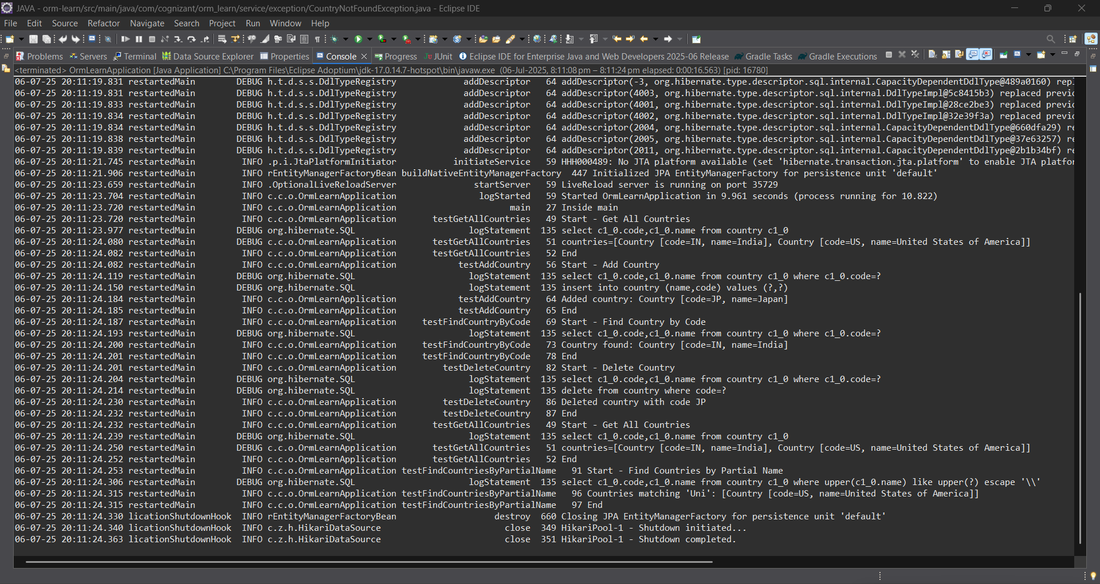

Exercise 7: Add a new country

Solution:
OrmLearnApplication.java
package com.cognizant.orm_learn;
import com.cognizant.orm_learn.model.Country;
import com.cognizant.orm_learn.service.CountryService;
import com.cognizant.orm_learn.service.exception.CountryNotFoundException;
import java.util.List;
import org.slf4j.Logger;
import org.slf4j.LoggerFactory;
import org.springframework.boot.SpringApplication;
import org.springframework.boot.autoconfigure.SpringBootApplication;
import org.springframework.context.ApplicationContext;
@SpringBootApplication
public class OrmLearnApplication {
private static final Logger LOGGER = LoggerFactory.getLogger(OrmLearnApplication.class);
private static CountryService countryService;
public static void main(String[] args) {
ApplicationContext context = SpringApplication.run(OrmLearnApplication.class, args);
countryService = context.getBean(CountryService.class);
LOGGER.info("Inside main");

testGetAllCountries();
testAddCountry();

testFindCountryByCode();
testDeleteCountry();
testGetAllCountries();
testFindCountriesByPartialName();
}
private static void testGetAllCountries() {
LOGGER.info("Start - Get All Countries");
List<Country> countries = countryService.getAllCountries();
LOGGER.debug("countries={}", countries);
LOGGER.info("End");
}
private static void testFindCountryByCode() {
LOGGER.info("Start - Find Country by Code");
try {
Country country = countryService.findCountryByCode("IN"); // Change "IN" to "JP" or other
LOGGER.info("Country found: {}", country);
} catch (CountryNotFoundException e) {
LOGGER.error("Exception: {}", e.getMessage());
}
LOGGER.info("End");
}
private static void testDeleteCountry() {
LOGGER.info("Start - Delete Country");
countryService.deleteCountry("JP");
LOGGER.info("Deleted country with code JP");
LOGGER.info("End");
}
private static void testFindCountriesByPartialName() {
LOGGER.info("Start - Find Countries by Partial Name");
String partialName = "Uni"; // Example input
List<Country> countries = countryService.findCountriesByPartialName(partialName);
LOGGER.info("Countries matching '{}': {}", partialName, countries);
LOGGER.info("End");
}
private static void testAddCountry() {
LOGGER.info("Start - Add Country");
Country country = new Country();
country.setCode("FR"); // Use a new unique code
country.setName("France");
countryService.addCountry(country);
LOGGER.info("Added country: {}", country);
try {
Country retrieved = countryService.findCountryByCode("FR");
LOGGER.info("Country fetched from DB: {}", retrieved);
} catch (Exception e) {
LOGGER.error("Country not found after adding: {}", e.getMessage());
}
LOGGER.info("End");
}
}
Output:
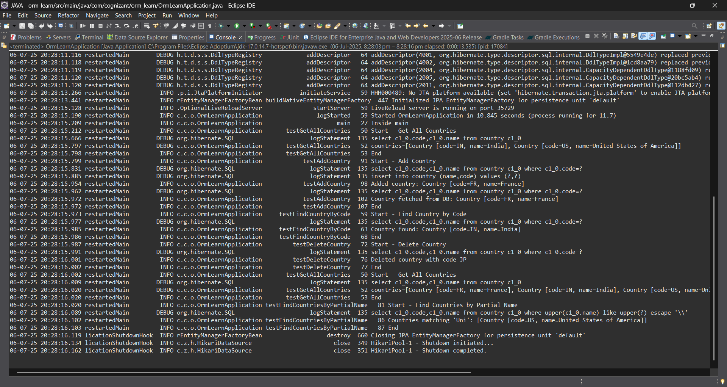
Demonstrate implementation of Query Methods feature of Spring Data JPA

Exercise 8: Update Country

- Add a new method updateCountry() in CountryService and CountryServiceImpl.
- Use @Transactional and save() to update the country name.
- Fetch the country using findCountryByCode() and update its name.

Exercise 9: Delete Country
- Use deleteById() in service layer to remove a country.

Solution for both:

CountryService.java

package com.cognizant.orm_learn.service;
import com.cognizant.orm_learn.model.Country;
import com.cognizant.orm_learn.service.exception.CountryNotFoundException;
import java.util.List;
import jakarta.transaction.Transactional;
public interface CountryService {
@Transactional
Country findCountryByCode(String code) throws CountryNotFoundException;

@Transactional
void addCountry(Country country);
@Transactional
void updateCountry(String code, String newName) throws CountryNotFoundException;
@Transactional
void deleteCountry(String code);
List<Country> findCountriesByPartialName(String name);
List<Country> getAllCountries();
}

CountryServiceImpl.java
package com.cognizant.orm_learn.service;
import com.cognizant.orm_learn.model.Country;
import com.cognizant.orm_learn.repository.CountryRepository;
import com.cognizant.orm_learn.service.exception.CountryNotFoundException;
import jakarta.transaction.Transactional;
import org.springframework.beans.factory.annotation.Autowired;
import org.springframework.stereotype.Service;
import java.util.List;
import java.util.Optional;
@Service
@Transactional
public class CountryServiceImpl implements CountryService {
@Autowired
private CountryRepository countryRepository;
@Override
public Country findCountryByCode(String code) throws CountryNotFoundException {
Optional<Country> result = countryRepository.findById(code);
if (!result.isPresent()) {
throw new CountryNotFoundException("Country not found with code: " + code);
}
return result.get();
}
@Override
public void addCountry(Country country) {
countryRepository.save(country);
}
@Override
public void updateCountry(String code, String newName) throws CountryNotFoundException {
Country existing = findCountryByCode(code); // reuse with exception handling
existing.setName(newName);
countryRepository.save(existing);
}
@Override
public void deleteCountry(String code) {
countryRepository.deleteById(code);
}
@Override
public List<Country> findCountriesByPartialName(String name) {
return countryRepository.findByNameContainingIgnoreCase(name);
}
@Override
public List<Country> getAllCountries() {
return countryRepository.findAll();
}
}

OrmLearnApplication.java
package com.cognizant.orm_learn;
import com.cognizant.orm_learn.model.Country;
import com.cognizant.orm_learn.service.CountryService;
import com.cognizant.orm_learn.service.exception.CountryNotFoundException;
import java.util.List;
import org.slf4j.Logger;
import org.slf4j.LoggerFactory;
import org.springframework.boot.SpringApplication;
import org.springframework.boot.autoconfigure.SpringBootApplication;
import org.springframework.context.ApplicationContext;
@SpringBootApplication
public class OrmLearnApplication {
private static final Logger LOGGER = LoggerFactory.getLogger(OrmLearnApplication.class);
private static CountryService countryService;
public static void main(String[] args) {
ApplicationContext context = SpringApplication.run(OrmLearnApplication.class, args);
countryService = context.getBean(CountryService.class);
LOGGER.info("Inside main");
testAddCountry();
testUpdateCountry();
testFindCountryByCode();
testDeleteCountry();
testGetAllCountries();
testFindCountriesByPartialName();
}
private static void testAddCountry() {
LOGGER.info("Start - Add Country");
Country country = new Country();
country.setCode("DE");
country.setName("Germany");
countryService.addCountry(country);
LOGGER.info("Added country: {}", country);
LOGGER.info("End");
}
private static void testUpdateCountry() {
LOGGER.info("Start - Update Country");
try {
countryService.updateCountry("DE", "Deutschland");
LOGGER.info("Updated country name for DE to Deutschland");
} catch (CountryNotFoundException e) {
LOGGER.error("Error updating country: {}", e.getMessage());
}
LOGGER.info("End");
}
private static void testFindCountryByCode() {
LOGGER.info("Start - Find Country by Code");
try {
Country country = countryService.findCountryByCode("DE");
LOGGER.info("Country found: {}", country);
} catch (CountryNotFoundException e) {
LOGGER.error("Exception: {}", e.getMessage());
}
LOGGER.info("End");
}
private static void testDeleteCountry() {
LOGGER.info("Start - Delete Country");
countryService.deleteCountry("DE");
LOGGER.info("Deleted country with code DE");
LOGGER.info("End");
}
private static void testGetAllCountries() {
LOGGER.info("Start - Get All Countries");
List<Country> countries = countryService.getAllCountries();
LOGGER.debug("countries={}", countries);
LOGGER.info("End");
}
private static void testFindCountriesByPartialName() {
LOGGER.info("Start - Find Countries by Partial Name");
List<Country> countries = countryService.findCountriesByPartialName("Uni");
LOGGER.info("Countries matching 'Uni': {}", countries);
LOGGER.info("End");
}
}

Output:
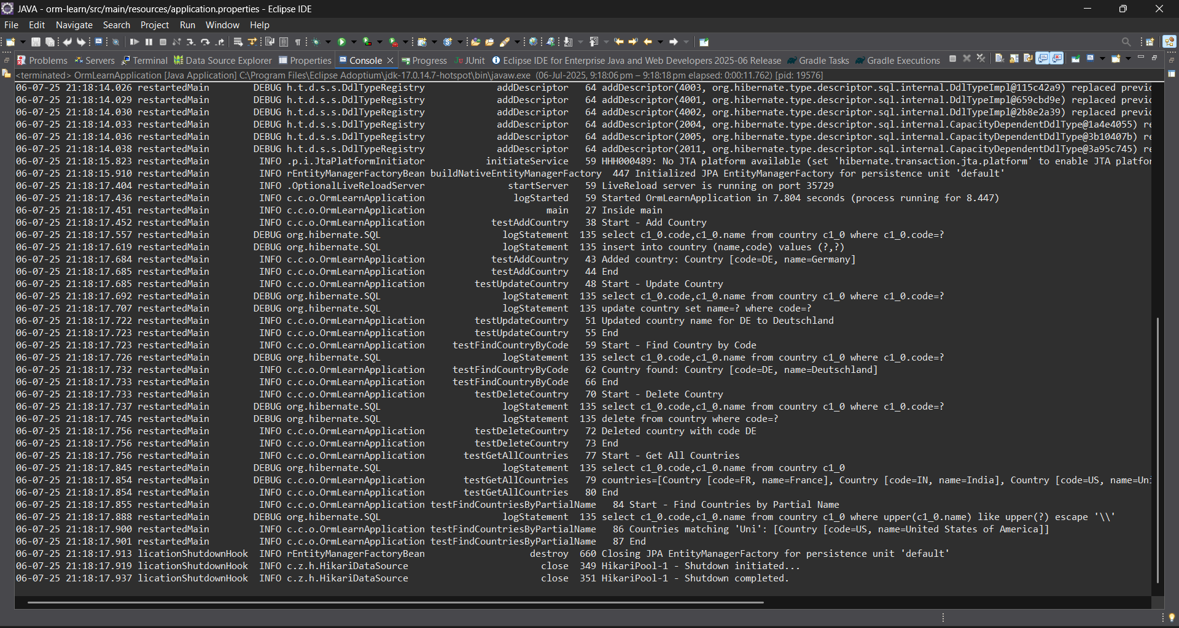

Demonstrate implementation of O/R Mapping
Exercise 3: Fetch quiz attempt details using HQL
- Username
- Attempted Date
- All questions as part of the attempt
- List of options under each quiz
- The option that is correct answer
- The score for correct answer
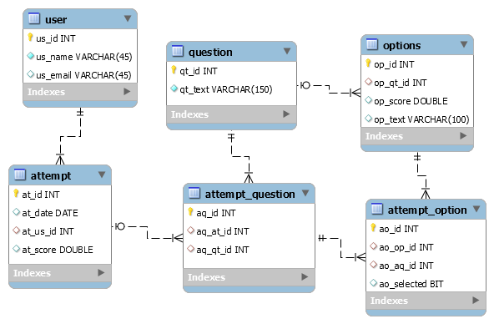
Exercise 4: Get average salary using HQL
Compute the average salary of a department using HQL.

Solution:
Employee.java
package com.cognizant.orm_learn.model;
import jakarta.persistence.*;
import java.util.Date;
import java.util.Set;
@Entity
@Table(name = "employee")
public class Employee {
@Id
@GeneratedValue(strategy = GenerationType.IDENTITY)
@Column(name = "em_id")
private int id;
@Column(name = "em_name")
private String name;
@Column(name = "em_salary")
private double salary;
@Column(name = "em_permanent")
private boolean permanent;
@Column(name = "em_date_of_birth")
private Date dateOfBirth;
@ManyToOne
@JoinColumn(name = "em_dp_id")
private Department department;
@ManyToMany(fetch = FetchType.EAGER)
@JoinTable(
name = "employee_skill",
joinColumns = @JoinColumn(name = "es_em_id"),
inverseJoinColumns = @JoinColumn(name = "es_sk_id")
)
private Set<Skill> skillList;
public int getId() { return id; }
public void setId(int id) { this.id = id; }
public String getName() { return name; }
public void setName(String name) { this.name = name; }
public double getSalary() { return salary; }
public void setSalary(double salary) { this.salary = salary; }
public boolean isPermanent() { return permanent; }
public void setPermanent(boolean permanent) { this.permanent = permanent; }
public Date getDateOfBirth() { return dateOfBirth; }
public void setDateOfBirth(Date dateOfBirth) { this.dateOfBirth = dateOfBirth; }
public Department getDepartment() { return department; }
public void setDepartment(Department department) { this.department = department; }
public Set<Skill> getSkillList() { return skillList; }
public void setSkillList(Set<Skill> skillList) { this.skillList = skillList; }
@Override
public String toString() {
return "Employee [id=" + id + ", name=" + name + ", salary=" + salary +
", permanent=" + permanent + ", dateOfBirth=" + dateOfBirth + "]";
}
}
Department.java
package com.cognizant.orm_learn.model;
import jakarta.persistence.*;
import java.util.Set;
@Entity
@Table(name = "department")
public class Department {
@Id
@GeneratedValue(strategy = GenerationType.IDENTITY)
@Column(name = "dp_id")
private int id;
@Column(name = "dp_name")
private String name;
@OneToMany(mappedBy = "department", fetch = FetchType.EAGER)
private Set<Employee> employeeList;
public int getId() {
return id;
}
public void setId(int id) {
this.id = id;
}
public String getName() {
return name;
}
public void setName(String name) {
this.name = name;
}
public Set<Employee> getEmployeeList() {
return employeeList;
}
public void setEmployeeList(Set<Employee> employeeList) {
this.employeeList = employeeList;
}
@Override
public String toString() {
return "Department [id=" + id + ", name=" + name + "]";
}
}
Skill.java
package com.cognizant.orm_learn.model;
import jakarta.persistence.*;
import java.util.Set;
@Entity
@Table(name = "skill")
public class Skill {
@Id
@GeneratedValue(strategy = GenerationType.IDENTITY)
@Column(name = "sk_id")
private int id;
@Column(name = "sk_name")
private String name;
@ManyToMany(mappedBy = "skillList")
private Set<Employee> employeeList;
public int getId() {
return id;
}
public void setId(int id) {
this.id = id;
}
public String getName() {
return name;
}
public void setName(String name) {
this.name = name;
}
public Set<Employee> getEmployeeList() {
return employeeList;
}
public void setEmployeeList(Set<Employee> employeeList) {
this.employeeList = employeeList;
}
@Override
public String toString() {
return "Skill [id=" + id + ", name=" + name + "]";
}
}
EmployeeRepository.java
package com.cognizant.orm_learn.repository;
import org.springframework.data.jpa.repository.JpaRepository;
import com.cognizant.orm_learn.model.Employee;
public interface EmployeeRepository extends JpaRepository<Employee, Integer> {}
DepartmentRepository.java
package com.cognizant.orm_learn.repository;
import org.springframework.data.jpa.repository.JpaRepository;
import com.cognizant.orm_learn.model.Department;
public interface DepartmentRepository extends JpaRepository<Department, Integer> {}
SkillRepository.java
package com.cognizant.orm_learn.repository;
import org.springframework.data.jpa.repository.JpaRepository;
import com.cognizant.orm_learn.model.Skill;
public interface SkillRepository extends JpaRepository<Skill, Integer> {}
EmployeeService.java
package com.cognizant.orm_learn.service;
import com.cognizant.orm_learn.model.Employee;
import com.cognizant.orm_learn.repository.EmployeeRepository;
import org.springframework.beans.factory.annotation.Autowired;
import org.springframework.stereotype.Service;
import jakarta.transaction.Transactional;
import org.slf4j.Logger;
import org.slf4j.LoggerFactory;
@Service
public class EmployeeService {
private static final Logger LOGGER = LoggerFactory.getLogger(EmployeeService.class);
@Autowired
private EmployeeRepository employeeRepository;
@Transactional
public Employee get(int id) {
LOGGER.info("Start");
return employeeRepository.findById(id).get();
}
@Transactional
public void save(Employee employee) {
LOGGER.info("Start");
employeeRepository.save(employee);
LOGGER.info("End");
}
}
DepartmentService.java
package com.cognizant.orm_learn.service;
import com.cognizant.orm_learn.model.Department;
import com.cognizant.orm_learn.repository.DepartmentRepository;
import org.springframework.beans.factory.annotation.Autowired;
import org.springframework.stereotype.Service;
import jakarta.transaction.Transactional;
@Service
public class DepartmentService {
@Autowired
private DepartmentRepository departmentRepository;
@Transactional
public Department get(int id) {
return departmentRepository.findById(id).get();
}
@Transactional
public void save(Department department) {
departmentRepository.save(department);
}
}
SkillService.java
package com.cognizant.orm_learn.service;
import com.cognizant.orm_learn.model.Skill;
import com.cognizant.orm_learn.repository.SkillRepository;
import org.springframework.beans.factory.annotation.Autowired;
import org.springframework.stereotype.Service;
import jakarta.transaction.Transactional;
@Service
public class SkillService {
@Autowired
private SkillRepository skillRepository;
@Transactional
public Skill get(int id) {
return skillRepository.findById(id).get();
}
@Transactional
public void save(Skill skill) {
skillRepository.save(skill);
}
}
OrmLearnApplication.java
package com.cognizant.orm_learn;
import com.cognizant.orm_learn.model.Department;
import com.cognizant.orm_learn.model.Employee;
import com.cognizant.orm_learn.model.Skill;
import com.cognizant.orm_learn.service.DepartmentService;
import com.cognizant.orm_learn.service.EmployeeService;
import com.cognizant.orm_learn.service.SkillService;
import org.slf4j.Logger;
import org.slf4j.LoggerFactory;
import org.springframework.boot.SpringApplication;
import org.springframework.boot.autoconfigure.SpringBootApplication;
import org.springframework.context.ApplicationContext;
import java.util.Date;
import java.util.HashSet;
import java.util.Set;
@SpringBootApplication
public class OrmLearnApplication {
private static final Logger LOGGER = LoggerFactory.getLogger(OrmLearnApplication.class);
private static EmployeeService employeeService;
private static DepartmentService departmentService;
private static SkillService skillService;
public static void main(String[] args) {
ApplicationContext context = SpringApplication.run(OrmLearnApplication.class, args);
employeeService = context.getBean(EmployeeService.class);
departmentService = context.getBean(DepartmentService.class);
skillService = context.getBean(SkillService.class);
LOGGER.info("Inside main");
testAddEmployee();
testUpdateEmployee();
testGetDepartment();
testAddSkillToEmployee();
}
private static void testAddEmployee() {
LOGGER.info("Start - testAddEmployee");
Employee employee = new Employee();
employee.setName("John Doe");
employee.setSalary(50000.0);
employee.setPermanent(true);
employee.setDateOfBirth(new Date());
Department department = departmentService.get(1);
employee.setDepartment(department);
employeeService.save(employee);
LOGGER.debug("Employee: {}", employee);
LOGGER.info("End");
}
private static void testGetEmployee() {
LOGGER.info("Start - testGetEmployee");
Employee employee = employeeService.get(1);
LOGGER.debug("Employee: {}", employee);
LOGGER.debug("Department: {}", employee.getDepartment());
LOGGER.debug("Skills: {}", employee.getSkillList());
LOGGER.info("End");
}
private static void testUpdateEmployee() {
LOGGER.info("Start - testUpdateEmployee");
Employee employee = employeeService.get(1);
Department newDept = departmentService.get(2);
employee.setDepartment(newDept);
employeeService.save(employee);
LOGGER.debug("Updated Employee: {}", employee);
LOGGER.info("End");
}
private static void testGetDepartment() {
LOGGER.info("Start - testGetDepartment");
Department department = departmentService.get(1);
LOGGER.debug("Department: {}", department);
LOGGER.debug("Employees: {}", department.getEmployeeList());
LOGGER.info("End");
}
private static void testAddSkillToEmployee() {
LOGGER.info("Start - testAddSkillToEmployee");
Employee employee = employeeService.get(1);
Skill skill = skillService.get(2);
Set<Skill> skillList = employee.getSkillList();
if (skillList == null) {
skillList = new HashSet<>();
}
skillList.add(skill);
employee.setSkillList(skillList);
employeeService.save(employee);
LOGGER.debug("Updated Employee with new skill: {}", employee);
LOGGER.info("End");
}
}
Output:
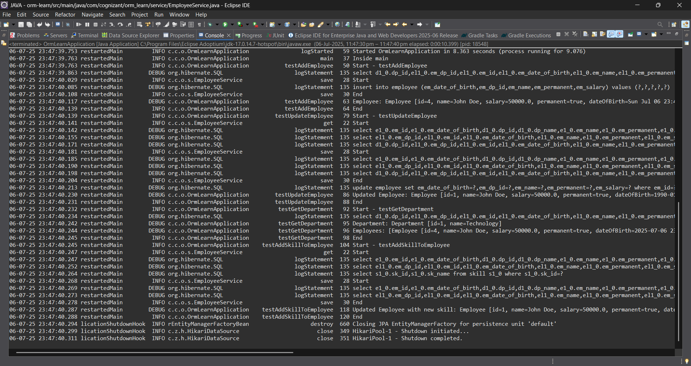

Demonstrate writing Hibernate Query Language and Native Query
Exercise 4: Get average salary using HQL
Compute the average salary of a department using HQL.
Exercise 5: Get all employees using Native Query
Solution for Both:

Employee.java
package com.cognizant.orm_learn.model;
import jakarta.persistence.*;
import java.util.Date;
import java.util.Set;
@Entity
@Table(name = "employee")
public class Employee {
@Id
@GeneratedValue(strategy = GenerationType.IDENTITY)
@Column(name = "em_id")
private int id;
@Column(name = "em_name")
private String name;
@Column(name = "em_salary")
private double salary;
@Column(name = "em_permanent")
private boolean permanent;
@Column(name = "em_date_of_birth")
private Date dateOfBirth;
@ManyToOne
@JoinColumn(name = "em_dp_id")
private Department department;
@ManyToMany(fetch = FetchType.EAGER)
@JoinTable(
name = "employee_skill",
joinColumns = @JoinColumn(name = "es_em_id"),
inverseJoinColumns = @JoinColumn(name = "es_sk_id")
)
private Set<Skill> skillList;
public int getId() { return id; }
public void setId(int id) { this.id = id; }
public String getName() { return name; }
public void setName(String name) { this.name = name; }
public double getSalary() { return salary; }
public void setSalary(double salary) { this.salary = salary; }
public boolean isPermanent() { return permanent; }
public void setPermanent(boolean permanent) { this.permanent = permanent; }
public Date getDateOfBirth() { return dateOfBirth; }
public void setDateOfBirth(Date dateOfBirth) { this.dateOfBirth = dateOfBirth; }
public Department getDepartment() { return department; }
public void setDepartment(Department department) { this.department = department; }
public Set<Skill> getSkillList() { return skillList; }
public void setSkillList(Set<Skill> skillList) { this.skillList = skillList; }
@Override
public String toString() {
return "Employee [id=" + id + ", name=" + name + ", salary=" + salary +
", permanent=" + permanent + ", dateOfBirth=" + dateOfBirth + "]";
}
}
Department.java
package com.cognizant.orm_learn.model;
import jakarta.persistence.*;
import java.util.Set;
@Entity
@Table(name = "department")
public class Department {
@Id
@GeneratedValue(strategy = GenerationType.IDENTITY)
@Column(name = "dp_id")
private int id;
@Column(name = "dp_name")
private String name;
@OneToMany(mappedBy = "department", fetch = FetchType.EAGER)
private Set<Employee> employeeList;
public int getId() {
return id;
}
public void setId(int id) {
this.id = id;
}
public String getName() {
return name;
}
public void setName(String name) {
this.name = name;
}
public Set<Employee> getEmployeeList() {
return employeeList;
}
public void setEmployeeList(Set<Employee> employeeList) {
this.employeeList = employeeList;
}
@Override
public String toString() {
return "Department [id=" + id + ", name=" + name + "]";
}
}
Skill.java
package com.cognizant.orm_learn.model;
import jakarta.persistence.*;
import java.util.Set;
@Entity
@Table(name = "skill")
public class Skill {
@Id
@GeneratedValue(strategy = GenerationType.IDENTITY)
@Column(name = "sk_id")
private int id;
@Column(name = "sk_name")
private String name;
@ManyToMany(mappedBy = "skillList")
private Set<Employee> employeeList;
public int getId() {
return id;
}
public void setId(int id) {
this.id = id;
}
public String getName() {
return name;
}
public void setName(String name) {
this.name = name;
}
public Set<Employee> getEmployeeList() {
return employeeList;
}
public void setEmployeeList(Set<Employee> employeeList) {
this.employeeList = employeeList;
}
@Override
public String toString() {
return "Skill [id=" + id + ", name=" + name + "]";
}
}
EmployeeRepository.java
package com.cognizant.orm_learn.repository;
import org.springframework.data.jpa.repository.JpaRepository;
import com.cognizant.orm_learn.model.Employee;
public interface EmployeeRepository extends JpaRepository<Employee, Integer> {}
DepartmentRepository.java
package com.cognizant.orm_learn.repository;
import org.springframework.data.jpa.repository.JpaRepository;
import com.cognizant.orm_learn.model.Department;
public interface DepartmentRepository extends JpaRepository<Department, Integer> {}
SkillRepository.java
package com.cognizant.orm_learn.repository;
import org.springframework.data.jpa.repository.JpaRepository;
import com.cognizant.orm_learn.model.Skill;
public interface SkillRepository extends JpaRepository<Skill, Integer> {}
EmployeeService.java
package com.cognizant.orm_learn.service;
import com.cognizant.orm_learn.model.Employee;
import com.cognizant.orm_learn.repository.EmployeeRepository;
import org.springframework.beans.factory.annotation.Autowired;
import org.springframework.stereotype.Service;
import jakarta.transaction.Transactional;
import org.slf4j.Logger;
import org.slf4j.LoggerFactory;
@Service
public class EmployeeService {
private static final Logger LOGGER = LoggerFactory.getLogger(EmployeeService.class);
@Autowired
private EmployeeRepository employeeRepository;
@Transactional
public Employee get(int id) {
LOGGER.info("Start");
return employeeRepository.findById(id).get();
}
@Transactional
public void save(Employee employee) {
LOGGER.info("Start");
employeeRepository.save(employee);
LOGGER.info("End");
}
}
DepartmentService.java
package com.cognizant.orm_learn.service;
import com.cognizant.orm_learn.model.Department;
import com.cognizant.orm_learn.repository.DepartmentRepository;
import org.springframework.beans.factory.annotation.Autowired;
import org.springframework.stereotype.Service;
import jakarta.transaction.Transactional;
@Service
public class DepartmentService {
@Autowired
private DepartmentRepository departmentRepository;
@Transactional
public Department get(int id) {
return departmentRepository.findById(id).get();
}
@Transactional
public void save(Department department) {
departmentRepository.save(department);
}
}
SkillService.java
package com.cognizant.orm_learn.service;
import com.cognizant.orm_learn.model.Skill;
import com.cognizant.orm_learn.repository.SkillRepository;
import org.springframework.beans.factory.annotation.Autowired;
import org.springframework.stereotype.Service;
import jakarta.transaction.Transactional;
@Service
public class SkillService {
@Autowired
private SkillRepository skillRepository;
@Transactional
public Skill get(int id) {
return skillRepository.findById(id).get();
}
@Transactional
public void save(Skill skill) {
skillRepository.save(skill);
}
}
OrmLearnApplication.java
package com.cognizant.orm_learn;
import com.cognizant.orm_learn.model.Department;
import com.cognizant.orm_learn.model.Employee;
import com.cognizant.orm_learn.model.Skill;
import com.cognizant.orm_learn.service.DepartmentService;
import com.cognizant.orm_learn.service.EmployeeService;
import com.cognizant.orm_learn.service.SkillService;
import org.slf4j.Logger;
import org.slf4j.LoggerFactory;
import org.springframework.boot.SpringApplication;
import org.springframework.boot.autoconfigure.SpringBootApplication;
import org.springframework.context.ApplicationContext;
import java.util.Date;
import java.util.HashSet;
import java.util.Set;
@SpringBootApplication
public class OrmLearnApplication {
private static final Logger LOGGER = LoggerFactory.getLogger(OrmLearnApplication.class);
private static EmployeeService employeeService;
private static DepartmentService departmentService;
private static SkillService skillService;
public static void main(String[] args) {
ApplicationContext context = SpringApplication.run(OrmLearnApplication.class, args);
employeeService = context.getBean(EmployeeService.class);
departmentService = context.getBean(DepartmentService.class);
skillService = context.getBean(SkillService.class);
LOGGER.info("Inside main");

testGetEmployee();
}
private static void testAddEmployee() {
LOGGER.info("Start - testAddEmployee");
Employee employee = new Employee();
employee.setName("John Doe");
employee.setSalary(50000.0);
employee.setPermanent(true);
employee.setDateOfBirth(new Date());
Department department = departmentService.get(1); // ensure this ID exists
employee.setDepartment(department);
employeeService.save(employee);
LOGGER.debug("Employee: {}", employee);
LOGGER.info("End");
}
private static void testGetEmployee() {
LOGGER.info("Start - testGetEmployee");
Employee employee = employeeService.get(1); // use valid employee id
LOGGER.debug("Employee: {}", employee);
LOGGER.debug("Department: {}", employee.getDepartment());
LOGGER.debug("Skills: {}", employee.getSkillList());
LOGGER.info("End");
}
private static void testUpdateEmployee() {
LOGGER.info("Start - testUpdateEmployee");
Employee employee = employeeService.get(1); // use valid employee id
Department newDept = departmentService.get(2); // different department ID
employee.setDepartment(newDept);
employeeService.save(employee);
LOGGER.debug("Updated Employee: {}", employee);
LOGGER.info("End");
}
private static void testGetDepartment() {
LOGGER.info("Start - testGetDepartment");
Department department = departmentService.get(1); // department with multiple employees
LOGGER.debug("Department: {}", department);
LOGGER.debug("Employees: {}", department.getEmployeeList());
LOGGER.info("End");
}
private static void testAddSkillToEmployee() {
LOGGER.info("Start - testAddSkillToEmployee");
Employee employee = employeeService.get(1); // valid employee id
Skill skill = skillService.get(2); // valid skill id not already assigned
Set<Skill> skillList = employee.getSkillList();
if (skillList == null) {
skillList = new HashSet<>();
}
skillList.add(skill);
employee.setSkillList(skillList);
employeeService.save(employee);
LOGGER.debug("Updated Employee with new skill: {}", employee);
LOGGER.info("End");
}
}
Output:
